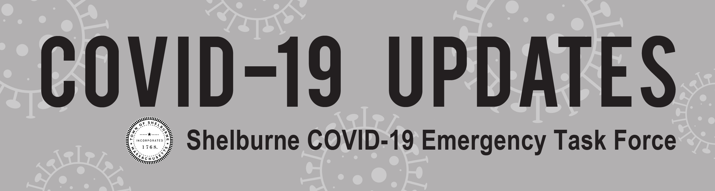

New Slow the Spread Orders ~ November 9, 2020
Governor Baker issued new orders and advisories to slow the spread of COVID-19 in an attempt to keep the economy and schools open after a 278% increase in cases and a 145% increase in hospitalizations since Labor Day. Among those are 68 new cases in Franklin County during October, a one-month high. The following new orders and advisories went into effect on Friday, November 6, 2020:
Face coverings required in public at all times (https://www.mass.gov/doc/covid-19-order-55/download).
- Residents over the age of 5 years are required to wear a mask or face covering over their nose and mouth in any public place, whether indoors or outdoors.
- Violations may result in a civil fine of up to $300 per violation.
Stay-At-Home advisory extended to specific hours (https://www.mass.gov/stayhome).
- In order to comply with this advisory, all residents must stay home between 10 PM and 5 AM.
  - Residents may only leave home to go to work or school, or for essential needs such as seeking medical care, or getting groceries or medical supplies during these hours.
  - Residents must not have gatherings in their home with anybody from outside of their household from 10 PM – 5 AM. (Please see further restrictions below.)
Gatherings at private residences restricted (https://www.mass.gov/doc/covid-19-order-54/download).
- Indoor gatherings are limited to 10 people and outdoor gatherings are limited to 25 people at private residences.
  - All gatherings must end and disperse by 9:30 PM.
  - Organizers of gatherings must report known positive COVID-19 cases to the local health department and cooperate with contact tracing.
  - Fines for violating the gathering order will be $500 for each person above the limit at a particular gathering.
Hours for certain businesses restricted (https://www.mass.gov/doc/covid-19-order-53/download).
- Restaurants and entertainments venues must close to the public each day between the hours of 9:30 PM and 5:00 AM.
- Sales and service of alcohol are also restricted after 9:30 PM.
If you or someone you know has a concern or need regarding these new orders and advisories, call 2-1-1.
If you or someone you know does not feel safe at home, call 1-800-799-7233 for live support. If you are unable to speak safely, log onto thehotline.org to chat online, or text LOVEIS to 22522.

