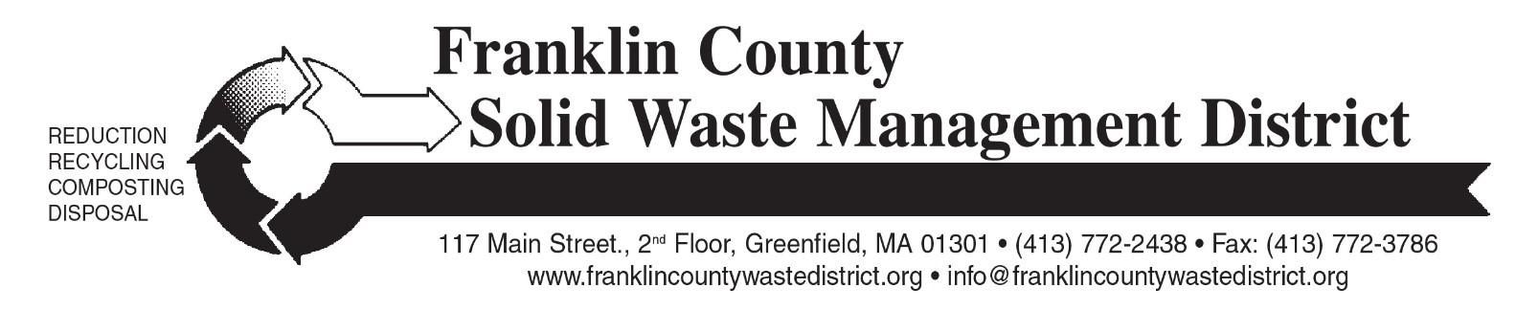

### ANNUAL HOUSEHOLD HAZARDOUS WASTE COLLECTION DAY

Franklin County Solid Waste District will hold the 2025 household hazardous waste collection on Saturday, September 20, at Greenfield Community College (GCC) and the Orange Transfer Station.

**Residents and businesses must pre-register by September 10th**. Online pre-registration for the 2025 collection will open in mid-August at [franklincountywastedistrict.org](https://franklincountywastedistrict.org/). Mail-in registration forms will be available in mid-August at town transfer stations and in local newspapers.

Participants will be assigned an appointment time to bring waste to the collection; an appointment time and instructions will be provided by mail after registration is processed.

The collection is free for residents of most of the District’s 21 member towns. Businesses may participate but must pay for disposal costs. For business registration information, call (413) 772-2438.

This event provides an opportunity to dispose of hazardous items that should not be put in the trash, such as leftover *oil-based* paints, stains, thinners, pesticides, herbicides, pool chemicals, motor oil, antifreeze, household cleaners, and other household chemicals. A more complete list of acceptable items is at [franklincountywastedistrict.org](https://franklincountywastedistrict.org/).

Batteries and mercury-containing items such as fluorescent light bulbs, thermometers, and thermostats are not accepted at this collection but should never be put in trash or recycling. Handle them carefully, bring them to a municipal transfer station or a [Regional Hazardous Waste “Super Site”](https://franklincountywastedistrict.org/p/17/) and hand to the attendant. Fluorescent light bulbs are also accepted at Lowe’s (all types of fluorescents), and Home Depot (CFLs only).

### Save the Date: Fall “Clean Sweep” Bulky Waste Recycling Day

The three collection locations on Saturday, October 18 (9 a.m. to noon) will be Erving Highway Garage on Public Works Boulevard (off Rt. 2); Mohawk Trail Regional School at26 Ashfield Rd. (Route 112 South), Buckland; and Whately Transfer Station at 73 Christian Lane in Whately.

Residents and businesses from any of the District’s 21 member towns may bring bulky items to this collection. There are charges for most items (cash only). A price list for the most common items is at: [franklincountywastedistrict.org](https://franklincountywastedistrict.org/). Pre-registration is not required for this event.

Acceptable items include tires, appliances, refrigerators, scrap metal, furniture, carpeting, construction debris, computers, televisions, propane gas tanks, textiles, books, bulky rigid plastics for recycling, and other large items. Materials will be recycled whenever possible.

### LOW-COST compost bins and pails

Composting is easy, and it can be even easier with effective, low-cost compost bins and pails. Franklin County Solid Waste District sells “Earth Machine” home compost bins ($25) and “Sure-Close” kitchen food waste collection pails ($5).

Residents of 16 District towns may purchase a compost bin for $25 through a subsidized pricing incentive provided by these towns (Bernardston, Buckland, Charlemont, Colrain, Conway, Deerfield, Erving, Gill, Leverett, Montague, New Salem, Northfield, Orange, Shelburne, Wendell, and Whately.) To purchase bins or pails, call the Solid Waste District at 413-772-2438.

For more information on any of these programs, visit [franklincountywastedistrict.org](https://franklincountywastedistrict.org/) or contact the District at [info@franklincountywastedistrict.org](mailto:info@franklincountywastedistrict.org), (413) 772-2438. *MA Relay for the hearing impaired: 711 or 1-800-439-2370 (TTY/TDD).* The District is an equal opportunity provider.