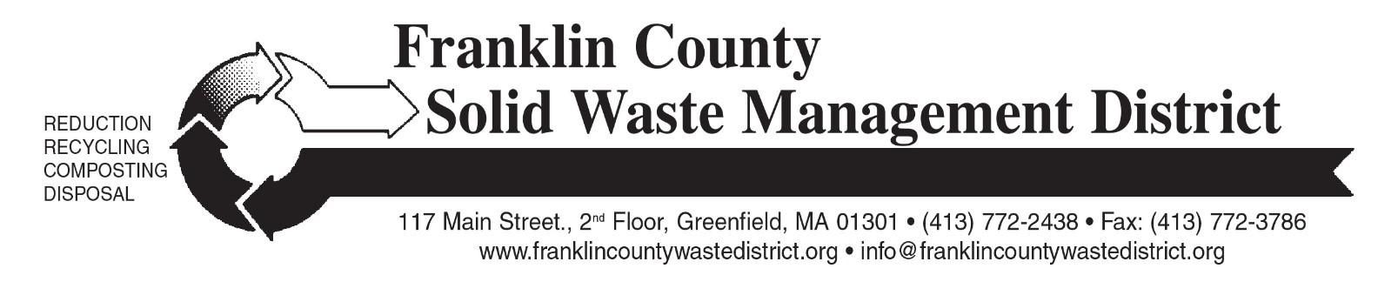

### ANNUAL HOUSEHOLD HAZARDOUS WASTE COLLECTION DAY

Franklin County Solid Waste District will hold the 2024 household hazardous waste collection on Saturday, September 21 at Greenfield Community College (GCC) and the Orange Transfer Station.

**Residents and businesses must pre-register by September 13th**. Online pre-registration for the 2024 collection will open on August 14, at: [franklincountywastedistrict.org](https://franklincountywastedistrict.org/). Mail-in registration forms will be available in mid-August at town transfer stations and in local newspapers.

Participants will be assigned an appointment time to bring waste to the collection; an appointment time and instructions will be provided by mail after registration is processed.

The collection is free for residents of most of the District’s 21 member towns. Businesses may participate but must pay for disposal costs. For business registration information, call (413) 772-2438.

This event provides an opportunity to dispose of hazardous items that should not be put in the trash, such as leftover oil-based paints, stains, thinners, pesticides, herbicides, pool chemicals, motor oil, antifreeze, household cleaners, and other household chemicals. A more complete list of acceptable items is at: [franklincountywastedistrict.org](https://franklincountywastedistrict.org/).

Batteries and mercury-containing items such as fluorescent light bulbs, thermometers, and thermostats are not accepted at this collection. These items, which may contain mercury or heavy metals, should never be put in trash or recycling. Handle them carefully, bring them to a municipal transfer station or a [Regional Hazardous Waste “Super Site”](https://franklincountywastedistrict.org/p/17/) and hand to the attendant. In addition, fluorescent light bulbs are accepted at Lowe’s Stores (all types of fluorescents), and Home Depot (CFLs only).

For more information visit: [franklincountywastedistrict.org](https://franklincountywastedistrict.org/) or contact the District at [info@franklincountywastedistrict.org](mailto:info@franklincountywastedistrict.org), (413) 772-2438. MA Relay for the hearing impaired: 711 or 1-800-439-2370 (TTY/TDD). The District is an equal opportunity provider.