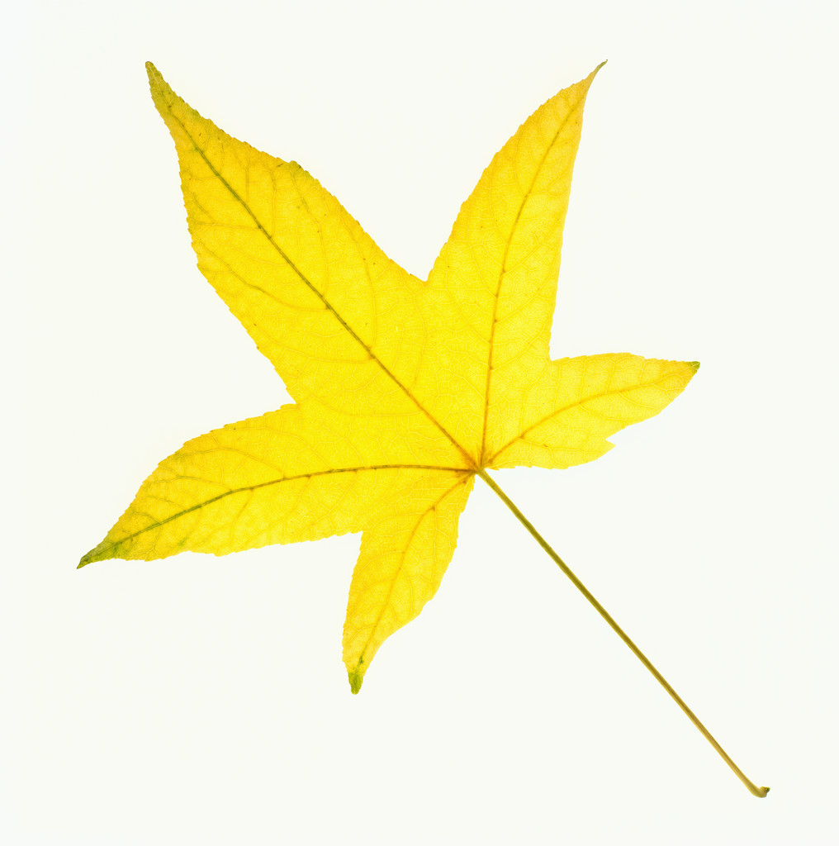
THE SHELBURNE HIGHWAY DEPARTMENT WILL BE
COLLECTING BAGGED LEAVES IN THE VILLAGE ON
TUESDAY,
APRIL 16, 2024
(WEATHER PERMITTING)
BAGS CONTAINING LEAVES ONLY SHOULD BE PLACE CURBSIDE BY 7:00 AM

