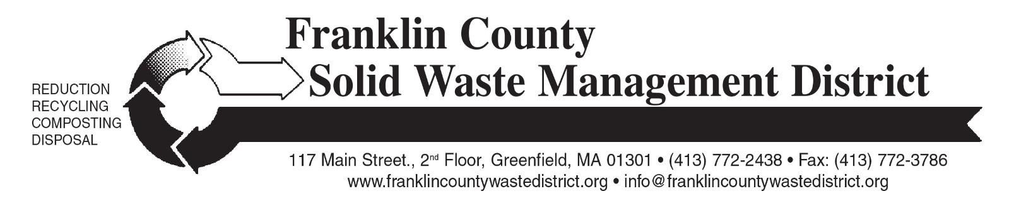

### Spring 2024 “Clean Sweep” Bulky Waste Recycling Day

Franklin County Solid Waste Management District is holding the Spring 2024 “Clean Sweep” Bulky Waste Recycling Day on Saturday, May 11 from 9 a.m. to noon. The three drop-off sites are: Erving Senior Center at 1 Care Dr (off Rt. 63) (*note new site instead of Northfield Highway Garage*); Mohawk Trail Regional School at26 Ashfield Rd. (Route 112 South); and Whately Transfer Station at 73 Christian Lane.

Residents from any of the District’s 21 member towns may bring bulky items such as tires, appliances, scrap metal, furniture, carpeting, construction debris, computers, televisions, propane gas tanks, and other large items. Materials will be recycled whenever possible.

There are charges for most items. Disposal fees, cash only, will be collected during check-in at each site. A complete list of prices for the most common items is at: [franklincountywastedistrict.org](https://franklincountywastedistrict.org/). The price list will also be provided to participating town halls and transfer stations. Residents and businesses do not need to pre-register for the collection.

Mattresses and box springs will not be accepted at this event. There are 6 regional mattress recycling locations across Franklin County. These sites are open various hours year-round. See this webpage for locations, pricing and hours: [franklincountywastedistrict.org/mattress-recycling](https://franklincountywastedistrict.org/mattress-recycling). If you are unsure if your mattress and box spring can be recycled, call the District office at 413-772-2438.

Electronics are accepted at the event, but residents are also encouraged to recycle computer equipment and televisions at their town’s transfer station, or at Greenfield Transfer Station. Staples stores accept computer equipment (no TVs) free of charge: call store for details.

Clean, dry textiles and books will be accepted for free reuse or recycling. Textiles must be contained inside a sturdy plastic bag. Textiles are now banned from the trash in Massachusetts. Textile recycling accepts 95% of all textiles and shoes, including clothing or linens that are torn, stained, with missing buttons or broken zippers. Damaged textiles can be sold to manufacturers that make insulation or shop rags. Acceptable items include CLEAN & DRY clothing, shoes, and accessories; plus curtains, sheets, towels and stuffed animals in any condition (except moldy or wet). Books can be in any condition (except moldy or wet) and can be hardcover or paperback. No encyclopedias.

Bulky Rigid Plastics will be collected separately for a special recycling program; $5 per load of acceptable items. This special recycling program only accepts these items: 5-gallon pails, plastic lawn furniture, plastic trash barrels, recycling bins, laundry baskets, storage totes, and milk crates. Bulky rigid plastic items must be empty.

Consider reuse: before sending items for disposal or recycling, see if someone else can use them. Various charities and non-profits accept donations of working electronics, including local Salvation Army and Goodwill stores. Always call ahead to ask if they can accept your item. Or, offer items for reuse on a local “Buy Nothing” Facebook group, Freecycle group, or local town groups such as NextDoor.

For more information, see [franklincountywastedistrict.org](https://franklincountywastedistrict.org/), or contact the District office at info@franklincountywastedistrict.org or 413-772-2438. *MA Relay for the hearing impaired: 711 or 1-800-439-2370 (TTY/TDD).* The District is an equal opportunity provider.