SHELBURNE COMMUNITY PRESERVATION GRANT
PRE-APPLICATION & APPLICATION INSTRUCTIONS

Welcome to the Shelburne Community Preservation Committee Application Process!

Thank you for your interest in applying for a grant from Shelburne Community Preservation funds. CPA funds are public funds raised from Shelburne property taxes and from State funding. Projects funded with CPA funds must meet all Town and State requirements for funds to be released. For more information about the Town of Shelburne’s Community Preservation Plan including mission and guiding principles, goals, state and local funding, see the plan document on the town’s website. Click here. We hope this process will be easy for you to follow and participate in. If any part of the process is unclear, please contact Communitypreservation@townofshelburnema.gov for more information. Thank you for your interest in making our town a better and more interesting place.

Included in this packet is information about:

- The purpose and limitations of the Community Preservation Act (CPA) (Please see chart on next page)
- Shelburne Community Preservation Committee’s (the Committee) role and processes
- CPA Grant eligibility
- Grant Application Process, Timeline and Deadlines
Grant Application Process:
- Pre-Application- Pre-Application is required for a project to be considered for funding. Before filling out the pre-application, review the allowable spending projects chart (see page 2). The (CPA) is clear about what can and cannot be funded with CPA funds. If your project does not fit into one or more of the “YES” boxes, the project does not qualify for funding. If you are unsure, complete a pre-application and the Committee will make a determination.
Deadline for submission of the pre-application is 5:00 PM September 15, 2025

The Committee will review all Pre-Applications and make initial determinations on project eligibility and notify Applicants in writing by October 30th. Applicants with projects that qualify can then proceed to the application process. Projects that do not qualify will receive feedback on why the project does not qualify for funding.
- Application- Applicants for projects that qualify through the Pre-Application process should move on to compete the full Application. Please complete all sections of the Application and attach additional documents if necessary. The Application will be considered complete upon submission and will be evaluated by the Committee as received. After an initial review, the Committee may request additional information.

Deadline for submission of the Application is 5:00 PM November 14, 2025.

The Committee will review your application within 6 weeks of submission. It is likely that we will have questions. We may ask them in writing or in person and may request additional documents. The Committee may also ask for a legal opinion on project eligibility. All Applicants will be invited to meet with the Committee to discuss their application and answer any questions. These meetings will be public and posted on the Town of Shelburne website (https://townofshelburne.com/).

The Committee may recommend the project as proposed or may modify it. It may recommend the full amount of funds requested or a lesser amount. It may also only fund a part of the project and not the entire project. Projects with more than one funding source are more likely to be approved.

After a thorough review of all Applications the Committee will vote whether or not to recommend funding of a project. If a project is recommended for funding, the Committee will prepare a warrant article for voter approval at Town Meeting. Applicants will be notified of the Town Meeting decision to fund their project and the amount funded along with information on how to proceed. Funds will not be available until after July 1^{st,} following approval at Town Meeting.

If your project is funded, The Committee and the Shelburne Town Administrator will help you understand the requirements and how to proceed.
All questions should be directed to Communitypreservation@townofshelburnema.gov

- Submission of documents:
The Pre-Application and Application can be submitted by the stated deadlines by any of the following methods. Only one copy is required. If you are using the fillable online pdf application, you must save the document offline as a pdf and submit the saved version.
  - Mail should be addressed to Shelburne Community Preservation Committee c/o Town Office, 51 Bridge Street, Shelburne Falls, MA 01370 and must be postmarked by 5 p.m. on November 19, 2024.
  - Email applications must be sent to: Communitypreservation@townofshelburnema.gov
  - Hand delivery must be received made to Town Office, 51 Bridge Street, Shelburne Falls, MA and received by a Town employee. You are responsible for confirming Town Office hours for hand delivery.
Pre-Application Deadline - 5:00 PM September 15, 2025
Application Deadline - 5:00 PM November 21, 2025

After funding and as you move ahead with your project, the Committee may ask you for updates on the progress of your project.
The Committee will provide all funded projects with signs indicating that money was provided through the CPA. These signs need to be displayed prominently while the project is moving forward and after it’s completed.

Community Presevation Guidelines for Eligibility
To qualify for funding, projects must fit within one of the categories listed on the top of this chart and one of the areas of action listed on the left side. For more information see the Shelburne Community Preservation plan document on the town’s website. Click here
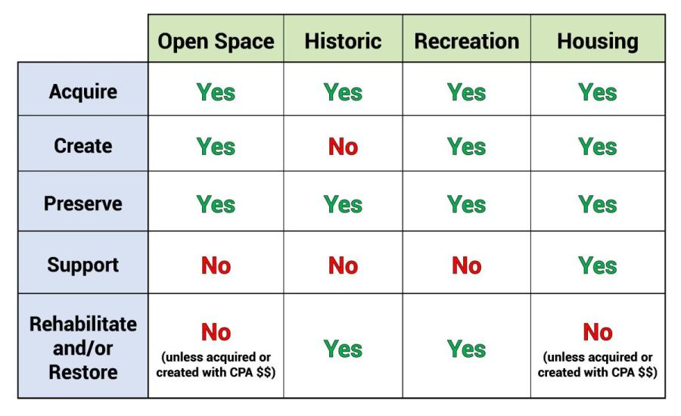
Community Preservation Act Allowable Uses of Funds Source: https://www.communitypreservation.org/allowable-uses

Community Preservation Grant Process- Application Timeline Overview:
- August Announcement that Shelburne CPA funds are available.
Grant application related materials posted on the Town website.
- September Grant Pre-Application Due by September 15 (Required)
- October Review of pre-applications and notification letters sent.
- November Grant Applications Due by November 21, 2025
- December Review of Applications
- January Committee meets with applicants to discuss projects.
- February Public Hearings to present proposed projects and solicits public comments.
- March Committee votes on project approval and prepares Town Meeting Warrant Articles
- April 1 Deadline for submitting warrant article for consideration at Town Meeting
- May Shelburne’s annual Town Meeting- vote on recommended projects
- June Notification of grant awards to Applicants

