

TOWN OF SHELBURNE

COMMUNITY PRESERVATION PLAN

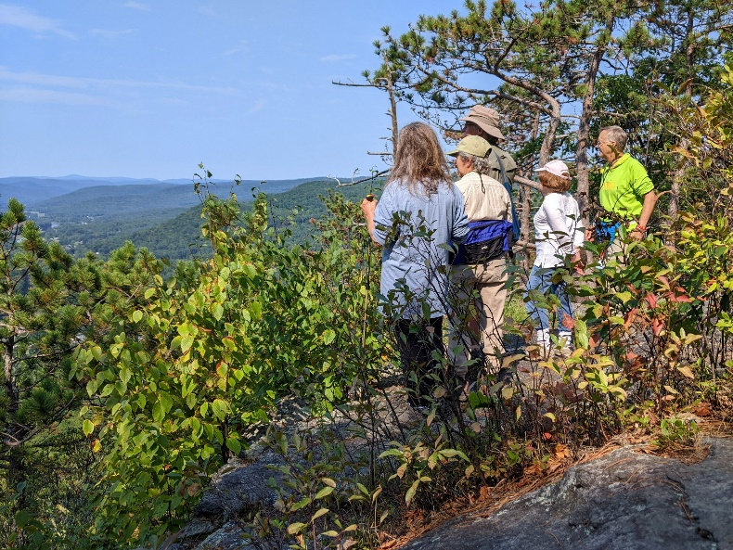2025

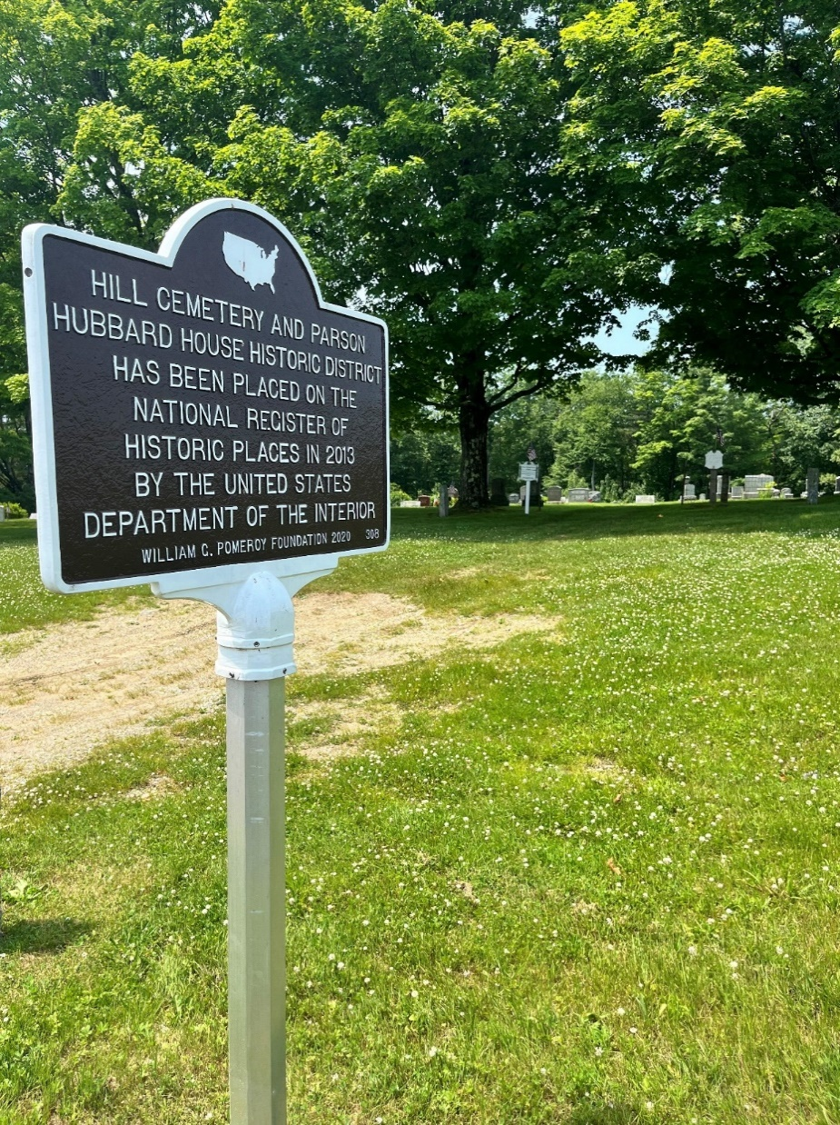

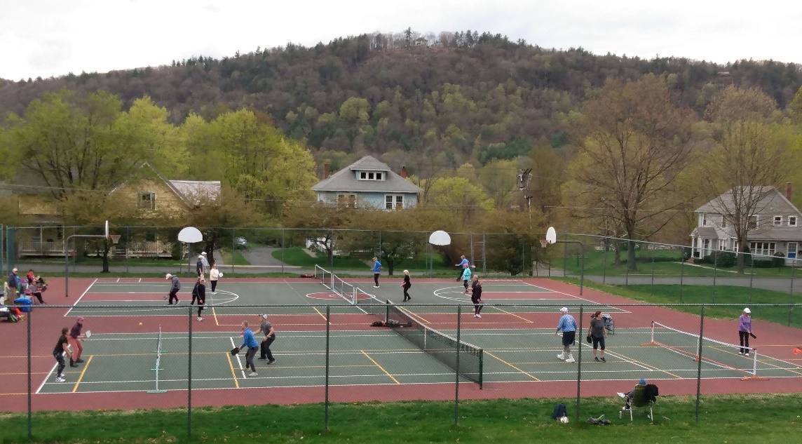

Shelburne Community Preservation Committee

Approved on August 13, 2024

August, 2024

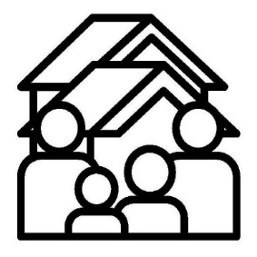

Dear Shelburne Residents,

As you may know, in 2022, the Shelburne community voted to adopt the Community Preservation Act (CPA) and in 2023, the Town passed a bylaw establishing the Community Preservation Committee (CPC). In late 2023, the CPC was sworn-in to implement and oversee this new program.

In a nutshell, CPA helps communities fund open space protection, historic preservation, affordable housing, and outdoor recreation.

A big part of the Committee’s job is to reach out to you, the Shelburne community, to explain how the CPA works, to get your input, and to learn your priorities.

We know that most of you have a deep appreciation for our community and a commitment to its future. We have learned that many of you have interesting ideas and opinions as to how CPA money should be spent.

We, on the Committee, are committed to inclusiveness and transparency as we continue to provide information and strive to administer the CPA effectively and efficiently. Our goal is to inspire applicants to bring us exciting and innovative projects that will provide broad benefits to the Shelburne community.

*Remember: the projects that will be considered for CPA funding do not originate with us. They originate with you!*

The CPC is pleased to present our second CPA plan which lays the foundation for our upcoming annual work and establishes the process for funding Shelburne’s preservation projects.

We, on the Committee, look forward to hearing from you and working with you this coming year. We hope you are as excited about Shelburne’s future as we are.

With warm regards from the Shelburne Community Preservation committee,

*Will Flanders, Chair*

*Jennifer Hale, Vice Chair*

*Phil*

*Mary Lou Gallup*

*Joan LaPierre*

*John MacGibbon*

*Carolyn Wheeler*

Table of Contents

Executive Summary 1

Plan Purpose 1

Planning Process 2

Summary of Identified Goals for CPA Funding 2

Chapter 1: Overview 2

Shelburne Community Profile 4

About the Community Preservation Act (CPA) 5

CPA Eligibility 6

Who May Apply for CPA Funds? 7

Membership and Role of Shelburne’s CPC 8

Chapter 2: Mission & Guiding Principles 10

Mission 10

Guiding Principles 10

Chapter 3: Estimated CPA Revenue and Application Process 12

Understanding the CPA Tax Surcharge in Shelburne 12

Estimated CPA Funds 12

Application & Funding Process 13

Project Execution 15

Chapter 4: Open Space 16

Open Space Context in Shelburne 16

Open Space Needs 18

CPA Eligibility 18

Open Space Goals 19

Chapter 5: Outdoor Recreation 20

Outdoor Recreation Context in Shelburne 20

Recreation Needs 20

CPA Eligibility 21

Recreation Goals 21

Chapter 6: Historic Preservation 23

Historic Preservation Context in Shelburne 23

Historical Preservation Needs 24

CPA Eligibility 24

Historic Resource Goals 25

Chapter 7: Community Housing 26

Housing Context in Shelburne 26

Community Housing Needs 30

CPA Eligibility 31

Community Housing Goals 32

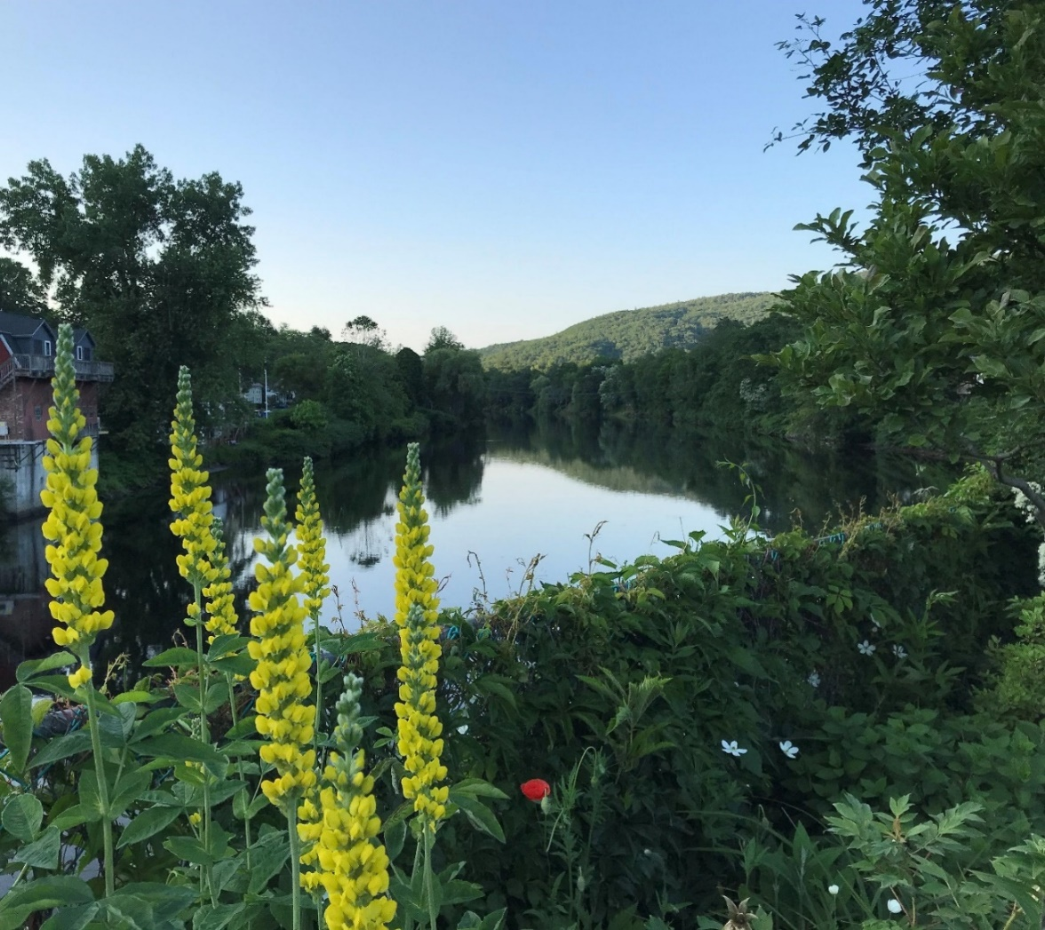

*Photo credits:*

*Cover page: Upper left, Joan LaPierre. Upper right, Jim Perry. Bottom: Mary Lou Gallup*

*Above: Andrea Donlon*

Executive Summary

Plan Purpose

The purpose of the Shelburne Community Preservation Plan is to serve as an informational document, a guideline and instructional document for applicants seeking project funding through the Community Preservation Act (CPA), and a guidance document for the Community Preservation Committee (CPC) in prioritizing funding and making recommendations to the Town for project funding.

The Community Preservation Act in Shelburne

The CPA is a Massachusetts statute enacted in 2000 that allows participating cities and towns to adopt a real estate tax surcharge of up to 3% in order to create a local Community Preservation Fund for the community preservation purposes of open space protection, outdoor recreation, historic preservation, and community housing.

In addition to the local tax surcharge, the Commonwealth of Massachusetts provides matching funds that are not less than 5% and not more than 100% of the funds raised by the community. The actual percentage varies from year-to-year dependent on the health of the Commonwealth’s community preservation trust fund, which is funded by a surcharge on Registry of Deeds transactions.

Shelburne residents voted to adopt the CPA at the 3% level by Town Meeting vote on June 11, 2022, and by ballot vote 59% yes/41% no on November 8, 2022. Accordingly, the Town Bylaws were amended by Town Meeting vote on May 2, 2023, to establish a Community Preservation Committee (CPC) to implement the CPA in Shelburne. The CPC formed in late 2023. CPC members received training from the Community Preservation Coalition, and this 2024 Community Preservation Plan is Shelburne’s inaugural plan to kick off the first round of CPA funding to be voted at Annual Town Meeting in May of 2025.

For additional information on the CPA and how it is being applied in municipalities across the Commonwealth, please visit the Community Preservation Coalition website at <https://www.communitypreservation.org/>.[1]

For information on Shelburne’s CPC, please visit the Town website at <https://townofshelburne.com/g/61/Community-Preservation-Committee>. The CPC meets monthly in meetings that are open to the public.

Planning Process

The Shelburne CPC planning process included the review of several plans developed by the Town of Shelburne over the last 10 years to identify Shelburne’s community preservation resources, needs and priorities in the four CPA funding categories: community housing, historic preservation, open space conservation, and outdoor recreation. The CPC worked with the Franklin Regional Council of Governments to prepare this Plan.

In accordance with the CPA Statute, the CPC consulted with the appropriate Town boards and commissions through its CPC member liaisons to the various committees, and incorporated comments received from board members. To encourage public participation in the Plan’s creation, the CPC held a public hearing on July 30, 2024 at the Shelburne Town Hall. In addition to six members of the CPC in attendance (plus FRCOG staff), 10 members of the public attended the hearing and provided input on the draft plan and application process.

As information and conditions are always changing, the plan will be updated over time.

Summary of Identified Goals for CPA Funding

Sections 4 through 7 discuss the context, needs, CPA eligibility, and goals of each of the CPA funding categories. Each category’s goals are listed below in one place.

Open space goals:

* Protect land that allows public access to open space, particularly lands along the Deerfield River.
* Promote and support the viability of farms and forests.
* Protect lands that have ecological, historical, agricultural, cultural, and recreational significance, including places that are significant to indigenous peoples.
* Protect lands that are wildlife corridors, sequester carbon, and are contiguous with other undeveloped tracts of land.
* Create public spaces in Shelburne Falls village where residents can meet, socialize, stay active, eat together, and/or enjoy arts and culture.

Outdoor recreation goals:

* Enhance and provide public access to the Deerfield River for fishing, swimming, and boating, particularly within the village.
* Expand the number of multi-use trails in Shelburne.
* Provide opportunities to link walking options in the Shelburne Falls village to locations outside the village.
* Maintain and expand the outdoor recreation options for people of all ages and abilities in Shelburne.
* Create public spaces in Shelburne Falls village where residents can meet, socialize, stay active, eat together, and/or enjoy arts and culture.
* Create a natural public swimming area in Shelburne.

Historic preservation goals:

* Preserve and protect Shelburne’s historic buildings, facades, and landscapes.
* Prioritize historic preservation projects that serve multiple public purposes.
* Preserve and repair headstones and markers at Shelburne’s cemeteries.
  + Shelburne Center Road Cemetery, Shelburne Center Road
  + South Cemetery, South Shelburne Road
  + Hill Cemetery, Old Village Road
  + Shelburne Center Cemetery, Percy Roberts Road
  + Arms Cemetery, Mechanic Street
* Provide accessibility at historic sites.

Community housing goals:

* Actively pursue and fund a variety of community housing initiatives to increase housing choice and enhance Shelburne’s diversity and vibrancy.
* Promote affordable, safe, ADA-accessible and energy efficient rental opportunities.
* Increase options for first-time and first-generation homebuyers.
* Support affordable housing for all ages, abilities and income levels.
* Support the creation of affordable units that count on the state’s Subsidized Housing Inventory, per MGL c.40B, by funding context-sensitive developments.
* Encourage the inventive reuse of existing buildings or new buildings on previously developed sites.

Chapter 1: Overview

Shelburne Community Profile

The town of Shelburne is an agricultural, light manufacturing, tourism, and residential community located in the hilltowns of Franklin County in northwestern Massachusetts. On the western edge of Shelburne is the village of Shelburne Falls, which has dense village housing and a picturesque downtown. The village area spans the Deerfield River, and the village itself straddles Shelburne and Buckland. The Bridge of Flowers, a former trolley bridge over the Deerfield River that is now a pedestrian bridge, is planted with trees and flowers and is an attraction for visitors and local residents. Outside of Shelburne Falls, Shelburne Center is close to the geographic center of town and has a library and a small cluster of housing in this rural residential setting. The rest of the town is much less densely developed, with much of it in forest and farmland.

In 1914, the Mohawk Trail (Route 2) was opened as an auto-touring route, and this transformed Shelburne into a tourist destination and stopover. The Route 2 travel corridor is also a Scenic Byway and is zoned for commercial development. Tourism continues to be a dominant driver of the town’s economy, as people visit the region for recreational and cultural opportunities. The Deerfield River runs along the west and southern border of Shelburne. Rising above and parallel to the Deerfield River is a ridge of mountains called Massaemett Mountain and the High Ledges. In the northern section of the town is the Patten district, which is a high elevation flat area with deep agricultural roots.

As of the 2020 Census, Shelburne’s population was 1,884. In 2020, 33% of Shelburne residents were 65 years or older, which is the highest percentage within communities in Franklin County. Just under 14% of residents were under the age of 18. Shelburne is not racially diverse, with 91% of residents identifying as White as of 2020.

According to the Massachusetts Bureau of Geographic Information (MassGIS) Environmental Justice Viewer, a part of Shelburne meets the definition of an Environmental Justice (EJ) population based on income, which means that the annual median household income for residents in this area is 65 percent or less of the statewide annual median household income. Shelburne’s EJ community comprises the Shelburne side of the village of Shelburne Falls, an area where approximately half the town’s population resides.[2]

Environmental Justice (EJ) is based on the principle that all people have a right to be protected from environmental hazards and to live in and enjoy a clean and healthful environment.[3] Some state and federal funding programs are targeted to EJ communities, and other state programs require additional outreach methods for EJ communities. With respect to the use of CPA funds in Shelburne, the CPC seeks meaningful involvement of all people in town and seeks to provide equitable distribution of benefits within the community. As such, the CPC may make additional efforts to solicit feedback and project ideas from the area of town that meets the definition of EJ.

Shelburne is a tight-knit community that is proud of its vibrant village and rural heritage and natural environment. With CPA funding as a new resource, our community seeks to invest in public projects that will protect, enhance, and support our unique community character, resources, and enrich the quality of life for all residents, and for generations to come.

About the Community Preservation Act (CPA)

The Community Preservation Act (CPA) is a state law, MGL Chapter 44B, enacted in 2000. The CPA creates an opportunity for communities to raise and set aside dedicated funds for community preservation projects that fall into four categories:

* Open Space & Recreation
* Historic Preservation
* Affordable Housing

CPA is funded annually through a combination of two sources — a local property tax surcharge (up to 3%) and a yearly distribution from the statewide Community Preservation Trust Fund which is overseen by the Massachusetts Department of Revenue (DOR).

Trust Fund revenues are derived from surcharges placed on all real estate transactions around the state at the Registries of Deeds. The Trust Fund match varies from year to year, depending on the availability of funds in relation to the number of state-wide real estate transactions, the number of communities participating in the CPA, and any additional appropriations from the legislature. Communities that adopt the 3% tax level are eligible for the highest matches. For additional information on the CPA statute and how it is being applied in municipalities across the state, visit the Community Preservation Coalition website at <https://www.communitypreservation.org/>.

Shelburne voters adopted the CPA in 2022 with a local surcharge of 3.0%. As of the beginning of 2024, 196 communities in Massachusetts have adopted the CPA, or 55% of the municipalities in Massachusetts.

CPA Eligibility

A minimum of 10% of annual CPA revenues must be spent or set aside in each of three categories: a) open space and recreation, b) affordable housing, and c) historic preservation. Up to 5% of annual revenue can be spent on operating expenses and clerical or administrative staff. The remaining 65% may be spent or allocated to any one or combination of the three CPA-eligible funding categories.

Who May Apply for CPA Funds?

Government entities and 501(c)3 nonprofits are eligible for CPA funds. In certain circumstances, private entities are eligible; these can be determined on a case-by-case basis.[4] Applicants do not have to be Shelburne organizations or residents; proposed projects must serve a public benefit by being in Shelburne or serving a public benefit to Shelburne residents.

Project eligibility for each CPA category is summarized below and more details are provided in later chapters of this Plan. Though open space and recreation are one funding category, they are listed below and in this Plan separately because they have slightly different requirements for funding.

### Open Space

CPA funds can be used to acquire, create, and preserve open space and natural resources and rehabilitate open space or natural resources if acquired or created through the CPA. Open space includes land to protect well fields, aquifers, watershed land, grassland, fields, forests, marshland, wetlands, land to protect scenic vistas, and land for wildlife preservation.

### Outdoor Recreation

CPA funds can be used to acquire, create, preserve, and rehabilitate land and outdoor facilities for recreational use. Recreational use includes active and passive outdoor recreation such as parks, playgrounds, and athletic fields. It does not include stadiums, bleachers, gymnasiums, or artificial turf for athletic fields.

### Housing

CPA funds can be used to acquire, create, and preserve affordable housing. CPA funds can also be used to support housing initiatives (such as rental assistance) and rehabilitate or restore housing that was acquired or created with CPA funding. Housing funded by CPA must be affordable to households with incomes at or below 100% of the area median income (AMI). The U.S. Department of Housing and Urban Development (HUD) guidelines determine area median income limits, and these are set by county. Affordability limits for Franklin County by household size is shown below.

|  |  |  |  |
| --- | --- | --- | --- |
| Household Size and FY2024 100% AMI Limits for Franklin County | | | |
| 1 $65,170 | **2** $74,480 | **3** $83,790 | **4** $93,100 |

Source: <https://www.communitypreservation.org/allowable-uses#anchor_housing>

### Historic Preservation

CPA funds can be used to acquire, preserve, and rehabilitate historic resources. Historic resources include buildings, structures, vessels, real property, landscapes, documents, or artifacts listed on the State Register of Historic Places or has been determined by the local Historical Commission to be significant in the history, archaeology, architecture, or culture of a city or town. (As defined by MGL Ch. 44B, Section 2).[5]

Historic resource proposals must comply with the [U.S. Secretary of the Interior’s Standards for the Treatment of Historical Properties](https://www.nps.gov/orgs/1739/secretary-standards-treatment-historic-properties.htm) for buildings or for landscapes.

The Community Preservation Coalition offers the handy chart below for determining what kinds of projects are eligible for CPA funding.

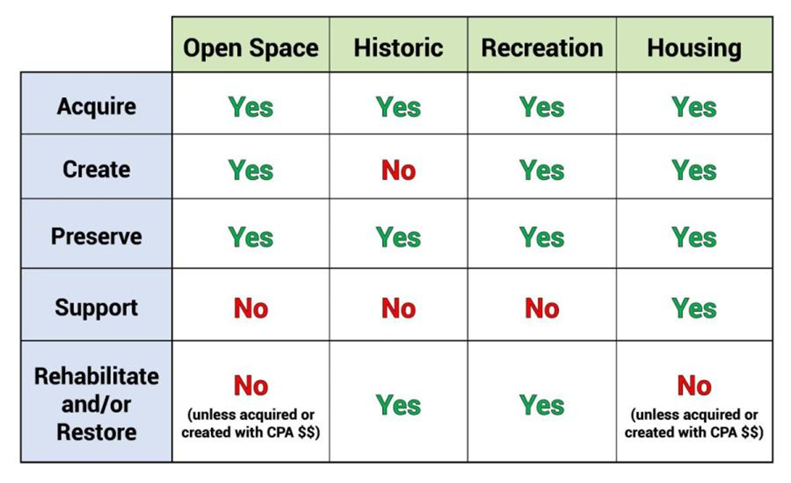

Source: <https://www.communitypreservation.org/allowable-uses>

Membership and Role of Shelburne’s CPC

The CPA Statute requires that the Town establish a Community Preservation Committee (CPC). Shelburne’s CPA Bylaw was passed in May of 2023, and established a CPC with nine members. There are five required members of the CPC, as follows: a member of the **Conservation Commission**, a member of the **Planning Board**, a member of the **Recreation Committee**, a resident who is not a town employee or serving on other town boards who is interested in promoting **historic preservation**, and a resident who is not a town employee or serving on other town boards who is interested in promoting **housing** in town. Additionally, there are four other members, as follows: a member of the **Open Space Committee**, a member of the **Agricultural Commission**, and **two at large member**s who are not town employees or serving on other town boards but are residents of Shelburne.

The CPC’s responsibilities are to study the community preservation needs, possibilities, and resources and to recommend the use of CPA funds for Town Meeting approval. As part of that process, the CPC updates this CPA Plan and creates a process for application and disbursal of CPA funds. The CPC shall also coordinate with applicable Town officials to prepare reports required under the CPA and to ensure that annual reporting is done in a timely manner.

Chapter 2: Mission & Guiding Principles

Mission

The Plan identifies the CPC’s mission and guiding principles, as well as target allocation goals and goals that are specific to each CPA funding category.

**The CPC’s mission** is to deploy CPA funds to enhance Shelburne’s unique identity as a peaceful and beautiful farming community with a busy and popular civic and business center that draws visitors from near and far to our small village. With this in mind, the CPC will support projects that:

* Promote community spirit, vibrancy, and diversity.
* Promote affordable housing to support long-term residents, seniors, and young families.
* Preserve and protect open spaces, including forest and farmland.
* Further climate resilience and protect native plants and animals.
* Enhance and preserve the public use, enjoyment, and knowledge of historic, recreational, and natural resources.

The principles and goals are briefly summarized below and described in more detail in the chapters to follow.

Guiding Principles

The CPC uses several guiding principles and goals to steer its deliberations and select projects to recommend to Town Meeting for funding. These principles are as follows:

1. **Leverage funds.**

Projects that expand the impact of CPA funds through leveraging other sources of funds, volunteer efforts, and/or donated materials, supplies, or property will be favored.

1. **Prioritize urgent projects.**

The CPC will analyze projects to determine the relative level of urgency of the work, and prioritize those projects that are more urgent.

1. **Advance projects with high community benefits.**

Projects that are important to the Town and demonstrate substantial community benefits, particularly those that are easily accessible to low income residents, will be advanced. Projects that address more than one CPA focus areas will also be given priority.

1. **Prioritize projects that involve multiple constituents.**

Projects that benefit multiple constituents will be scored more favorably and prioritized for funding.

1. **Ensure CPA investments are maintained over the long term.**

Projects should demonstrate planning and the finances for ongoing maintenance, so that CPA investments will be protected.

At the July 2024 public hearing, attendees were given a set of 7 dried beans and asked to “vote” for their favorite CPA funding type by dropping beans into mason jars labeled for outdoor recreation, open space, housing, and historical preservation. Vote counts were as follows: open space-22, affordable housing-20, historic preservation-19, and recreation-16. As hearing attendance was low and the votes close to equal, no priority was strongly identified, other than noting that the open space and recreation topics combined (38) were higher than other categories, and this could be viewed as a priority for the Town. In this inaugural CPC Plan, the CPC is identifying priorities in each category of funding. These priorities in no way excludes other projects that are eligible for CPA funding from consideration.

* **Improve outdoor public recreation opportunities.**

Projects that increase and improve outdoor recreation, particularly projects that concern trails and access to the Deerfield River, will be prioritized.

* **Protect high value open space.**

Open space protection projects should demonstrate protection of farmland, aquatic habitat, forests, indigenous cultural practices, and state-listed species or communities.

* **Create more units of affordable housing.**

Projects that create and preserve diverse types of affordable housing and assist low-income households with housing costs will be prioritized.

* **Preserve Shelburne’s history.**

Projects that preserve Shelburne’s indigenous, industrial, and agricultural history will be prioritized, as will projects within the Shelburne Falls Historic District.

Chapter 3: Estimated CPA Revenue and Application Process

Understanding the CPA Tax Surcharge in Shelburne

Shelburne residents voted to adopt the CPA on November 8, 2022. CPA funds are raised through a 3% property tax surcharge on all real estate property tax bills. The first $100,000 of the assessed value of residential, commercial, and industrial properties are automatically exempt from the surcharge. Low-income residents and moderate-income seniors can apply for a CPA exemption each year – forms are available at the Shelburne Town Hall.

The Town calculates the anticipated tax surcharge revenue for the upcoming Fiscal Year (FY) and designates the funding amounts for the specific reserves, administration, and undesignated reserve. Collection of the Shelburne CPA surcharges begins on July 1 of each FY. Massachusetts state matching funds for the previous year are distributed in November.

For FY2024, Shelburne homeowners have paid an average of $93.98 for the CPA surcharge. This amount will change year to year. Below shows an example for FY2024.

|  |  |
| --- | --- |
| **CPA Surcharge Example** |  |
| Average assessed home value FY 2024[6] | $336,253 |
| Residential exemption ($100,000) | -(100,000) |
| Total taxable value | $236,253 |
| FY2024 Residential Tax Rate per $1,000[7] | 13.26 |
| Property Tax Due (236,253 x 0.01326) | $3,132.71 |
| **CPA 3% Tax Surcharge** (3,132.71 x 0.03) | **$93.98** |

Estimated CPA Funds

For this first year of having CPA funds, the CPC estimates the Town of Shelburne will collect $80,720 from tax surcharges for FY2024. In November of 2024, Shelburne will be eligible for its first state match. Small towns that have passed the highest rate (3%) often receive a state match of 100%. Conservatively, we are estimating an 80% match. Therefore, we anticipate for the 2025 grant round, we will have the following amounts of funding available, shown in the table below. Actual amounts will be different and will be determined after the state match is received. Below is an estimate on the amount of money in each CPA account. The “Budgeted Reserve” account is not tied to a specific CPA project type, and can be used for any combination of eligible CPA projects.

|  |  |
| --- | --- |
| **CPA Funds Available** | **FY2024** |
| **Estimated Revenue** |  |
| CPA Surcharge | $80,720 |
| State Match | $64,000 |
| **Total Estimated Revenue** | **$144,720** |
| **SPECIFIC RESERVES** |  |
| Annual Administrative Fund (5%) | $7,236 |
| Open Space/Recreation (10%) | $14,472 |
| Community Housing (10%) | $14,472 |
| Historic Preservation (10%) | $14,472 |
| Budgeted Reserve (65%) | $94,068 |

Application & Funding Process

The CPC accepts applications from project proponents according to the following schedule. We anticipate the CPA application and funding cycle to take place between August and May of each year. During the summer, the CPC will meet less often, but may also spend that time updating this CPA Plan and potentially seeking public input on priorities.

Please note that pre-applications are required and must be submitted by September 15th. The CPC reviews all pre-applications and applications during regularly scheduled CPC meetings that are open to the public. Residents are invited to attend these meetings and provide input to the CPC on applications. More specific information is provided in the Application. The CPA application and guidelines for project submission are available on the Town’s website at <https://townofshelburne.com/g/61/Community-Preservation-Committee>.

If there are projects that require emergency funds, due to natural disaster or a project going up for sale that requires immediate action, an applicant can get in touch with the CPC and prepare an application outside of this cycle. We expect out-of-time applications to be rare and used only in the case of an urgent need.

The following timeline summarizes the different steps.

Project Execution

Funding for approved projects will be available following the issuance of the award letter, subject to conditions contained in the award letter. All CPA funds are administered and disbursed by the Town of Shelburne and will follow state procurement laws (M.G.L. Chapter 30B). Each funded project will have a holding account for the project set up by Shelburne’s Town Accountant. When applying for CPA funding, it is advisable to get estimated costs for products and services in order to develop your project budget. Once the project is approved at Town Meeting, the group sponsoring the project will need to get quotes and/or bids for specific expenditures, with the level of formality scaled to the size of the expenditure. The Town Accountant and Town Administrator have forms to use as models for quote requests and requests for proposals. Sponsoring groups that are not part of Town government will work closely with the Town Accountant and Town Administrator on procurements. Upon selection of a vendor or contractor, the sponsor will present information to the Shelburne Select Board for approval. Vendors will ultimately submit bills to the Town Accountant, Tax Collector and Town Administrator, and payments will come from project-specific accounts established when the project was initially approved.

The CPC may request project status updates from Fund recipients. The purpose of such update is to aid the CPC in refining this Plan and to identify issues that may assist future applicants.

**Funded projects must publicly display and credit CPA funding.**

Please contact the CPC if you have any questions about the CPA or the funding process. The CPC can be reached by email at [**communitypreservation@townofshelburnema.gov**](mailto:communitypreservation@townofshelburnema.gov), and the CPC’s members are listed on the CPC’s page on the Shelburne Town website.

Chapter 4: Open Space

This chapter provides information on Shelburne’s existing open space, identified needs and goals for open space, CPA eligibility for open space projects, and open space priorities. Much of the information in this section is derived from the *2024 Shelburne Open Space and Recreation Plan*. Please note that the spending requirements in the CPA law combines the Open Space and Outdoor Recreation categories. This CPC plan separates the two categories to clarify the Town’s needs, goals, and project eligibility for Open Space and Outdoor Recreation.

Section 2 of the Massachusetts CPA legislation defines **open space** as follows:

“Open space”, shall include, but not be limited to, land to protect existing and future well fields, aquifers and recharge areas, watershed land, agricultural land, grasslands, fields, forest land, fresh and salt water marshes and other wetlands, ocean, river, stream, lake and pond frontage, beaches, dunes and other coastal lands, lands to protect scenic vistas, land for wildlife or nature preserve and land for recreational use.

Open space provides for actively managed farm and forestland, wildlife habitat, native vegetation, protection and recharge of groundwater, public access to recreational lands and trail systems, protection and access to rivers, landscapes that represent the community’s heritage, and scenic views. Many of these features are vital to climate resilience.

Open Space Context in Shelburne

Shelburne is a beautiful agricultural town with a vibrant downtown village. The town borders the Deerfield River and there are several streams that flow to the Deerfield River or one of its tributaries. Shelburne’s 14,973 acres (23.4 square miles) are 74% forested, 13% agricultural, and 13% either residential, industrial, transportation, mixed use, or open water. More than half the land area in Shelburne has either temporary or permanent land protection, as summarized in the pie chart below. Of the permanently protected land in Shelburne, more than half is privately owned in the form of Agricultural Preservation Restrictions (APRs) or conservation restrictions. The following three nonprofits own permanently protected land in Shelburne: Mass Audubon, New England Forestry Foundation, and the Franklin Land Trust.

Land under limited or temporary protection includes mostly privately-owned parcels enrolled in Massachusetts Chapter 61 Current Use Tax Programs—61 (forestry), 61A (agriculture), and 61B (open space/recreation). These programs offer landowners reduced local property taxes in return for maintaining land in productive forestry, agricultural or recreational use, or in a wild condition for a period of time. Chapter 61 lands, also called “chapter lands,” provide many public benefits, from maintaining wildlife habitat and recreational open space to sustaining rural character and local forest and farm-based economic activity.

A benefit of the Chapter 61 programs is that they offer Town governments the opportunity to protect land. When a parcel that is currently enrolled in one of the Chapter 61 programs is proposed for conversion to a use that would make it ineligible for the program, the Town is guaranteed a 120-day waiting period during which it can exercise its Right-of-First-Refusal to purchase the property. Shelburne has a “Select Board Chapter 61 Right of First Refusal policy” that is linked on the Select Board documents web page.

One tool for evaluating the value of open space land is BioMap tool created by MassWildlife and the Nature Conservancy. In Shelburne, BioMap core habitat is located along Sluice Brook and Great Brook, in the High Ledges area (already conserved) and on Shingle Hill between Taylor Road and Zerah Fisk Road. The High Ledges area is already permanently protected, and some of these other areas are under temporary Chapter 61 protection.

Open Space Needs

Shelburne residents, business owners, and property owners who responded to the Open Space and Recreation Survey in late 2022 and early 2023 overwhelmingly felt that preserving the rural and agricultural character of Shelburne was extremely important. They placed clean drinking water, rivers and streams, clean air, ponds and wetlands, wildlife corridors, large blocks of forest, pollinator habitat, preserving scenic views, and maintaining farmland as open space as their top open space priorities (in that order from higher to lower). Access to public spaces was a top interest that residents mentioned many times. Trails, the Deerfield River, and farming were other strong interests. Additionally, over 80% of responders were very or somewhat interested in recognizing the indigenous heritage of the land when thinking about open space protection in town.

When asked about specific areas in town that should be protected, Shelburne residents most commonly mentioned the Deerfield River (62 mentions out of 104 responses), and the Potholes area downstream of the Deerfield No. 3 Dam was second. Patten Hill or the Patten District and Wilcox Hollow were also high priorities. A property located just over the town line in Charlemont at the confluence of the North and Deerfield Rivers, known locally as Sunburn Beach, was mentioned many times. Though this property is outside of the town boundaries, it represents one of the few swimming holes in or near Shelburne, where both parking and access for swimming has been increasingly restricted over the last several years.

CPA Eligibility

CPA funds may be spent on the *acquisition*, *creation*, and *preservation* of open space, and for the rehabilitation or restoration of any open space that has been acquired or created using CPA funds.[8] It is important to note that a permanent deed restriction is required for all real property interests acquired under CPA. This restriction must be filed as a separate instrument, such as a Conservation Restriction (CR) or Agricultural Preservation Restriction (APR).

Open space includes, but is not limited to, the following:

* Land to protect existing and future well fields
* Aquifers, recharge areas, and watershed land
* Agricultural land
* Grasslands, fields and forest land
* Fresh water marshes and other wetlands
* River, stream, lake and pond frontage
* Lands to protect scenic vistas
* Land for wildlife or nature preserve
* Open space properties may allow passive recreation (see separate category information in the next section for active and passive recreation projects)

Open Space Goals

The CPC has identified the following evaluation criteria for Open Space proposals. These criteria were developed with the needs and goals in mind from the 2024 Open Space and Recreation Plan, outreach to the Open Space Committee and Agricultural Committee, and public input.

The CPC will support Open Space proposals that meet one or more of the following objectives:

* Protect land that allows public access to open space, particularly lands along the Deerfield River.
* Promote and support the viability of farms and forests.
* Protect lands that have ecological, historical, agricultural, cultural, and recreational significance, including places that are significant to indigenous peoples.
* Protect lands that are wildlife corridors, sequester carbon, and are contiguous with other undeveloped tracts of land.
* Create public spaces in Shelburne Falls village where residents can meet, socialize, stay active, eat together, and/or enjoy arts and culture.

Chapter 5: Outdoor Recreation

This chapter provides information on Shelburne’s existing recreation offerings, identified needs and goals for recreation, CPA eligibility for recreation projects, and recreation priorities. Much of the information in this section is from the *2024 Shelburne Open Space and Recreation Plan*. Please note that the spending requirements in the CPA law combines the Open Space and Outdoor Recreation categories. This CPC plan separates the two categories to clarify the Town’s needs, goals, and project eligibility for Open Space and Outdoor Recreation.

Outdoor Recreation Context in Shelburne

Shelburne has a few recreational facilities under Town management. At the Cowell Gymnasium property, the Town of Shelburne maintains outdoor tennis, pickleball, and basketball courts for public use. There are also two public baseball and softball fields, at the Arms Academy property on Maple Street and at Little Mohawk Field on Little Mohawk Road. The Town of Shelburne also owns the Fire Tower on Massaemett Mountain that is a popular hiking destination on publicly accessible private trails. Other municipal properties that are owned by entities other than the Town of Shelburne that offer recreation are the Bridge of Flowers, Buckland-Shelburne Elementary School, and cemeteries in town. Other Town-owned properties either offer pocket parks (such as the flower garden near the Potholes) or are possible future sites for trails or other options. The remaining outdoor recreation offerings in Shelburne are on private or nonprofit land. These include trails, natural areas, Wilcox Hollow river access, an 18-hole chip and putt golf course, and apple picking at apple orchards.

The top outdoor recreation activities that community members who responded to the Open Space and Recreation Survey in late 2022 and early 2023 reported doing in or near Shelburne are as follows: walking/jogging, hiking, gardening, birdwatching/nature observation, swimming, photography, forest bathing, bicycling, paddling, dog walking, skiing, and sledding.

Recreation Needs

In the Open Space and Recreation Community Survey in late 2022 and early 2023, the highest priority for recreation was river access for swimming, fishing, paddling, and access to the Potholes. Other top priorities were walking and hiking trails that can also be used for cross-country skiing and snowshoeing in the winter, bike lanes and trails, on- and off-leash dog walking areas, a community garden, hunting access, and parks in the village.

CPA Eligibility

CPA funds may be used to acquire land to be used for recreation, or for the creation of new permanent outdoor recreational facilities on land a community already owns. A 2012 amendment to CPA broadened the law to also allow for the rehabilitation of existing, outdoor recreational facilities. The amendment made it clear that with respect to land for recreational use, "rehabilitation" could include the replacement of playground equipment and other capital improvements to the land or the facilities thereon to make them more functional for their intended recreational use.

CPA funds may not be spent on ordinary maintenance or annual operating expenses; only capital improvements are allowed. In addition, CPA funds may not be used for horse or dog racing facilities, or for a stadium, gymnasium, or similar structure. This prohibition has generally been interpreted to mean that CPA funds may be used only for outdoor, land-based recreational uses and facilities. The CPA law prohibits the use of CPA funds for the acquisition of artificial turf for athletic fields.

The focus for CPA recreational projects is on outdoor passive or active recreation, such as (but not limited to) the use of land for:

● Trails

● Noncommercial youth and adult sports

● Parks, playgrounds or athletic fields

● Community gardens

Recreation Goals

The CPC has identified the following evaluation criteria for Recreation proposals. These criteria were developed with the needs and goals in mind from the 2024 Open Space and Recreation Plan, outreach to the Recreation Committee and Open Space Committee, and public input.

The CPC will support recreation proposals that meet one or more of the following objectives:

* Enhance and provide public access to the Deerfield River for fishing, swimming, and boating, particularly within the village.
* Expand the number of multi-use trails in Shelburne.
* Provide opportunities to link walking options in the Shelburne Falls village to locations outside the village.
* Maintain and expand the outdoor recreation options for people of all ages and abilities in Shelburne.
* Create public spaces in Shelburne Falls village where residents can meet, socialize, stay active, eat together, and/or enjoy arts and culture.
* Create a natural public swimming area in Shelburne.

Chapter 6: Historic Preservation

This chapter describes Shelburne’s CPA historic preservation context, identified needs, CPA eligibility, and historical preservation goals.

Historic Preservation Context in Shelburne

There is evidence of indigenous habitation of the area that is now Shelburne for 2,500 years prior to the present period, but more information is known about Shelburne’s recent history of the last few centuries. Between the mid 1700’s and now, Shelburne has been an industrial manufacturing town in the village area near the Deerfield River, and an agricultural town in the areas outside the village. Agriculture still plays an important role and many farms and orchards continue to operate. The dominant industries in town were cutlery and forged tool manufacturing, in addition to box making, fabric and knitting mills, and farm implement and hardware manufacturing. Since the early 20th century, there has been a shift from manufacturing to tourist-related businesses such as restaurants and retail establishments. The Bridge of Flowers, a former trolley bridge over the Deerfield River between Shelburne and Buckland, is a popular spot for visitors and residents alike. Shelburne Falls has a strong artistic community, which is evident with the many art galleries and studios located in the village. In 2018, Shelburne celebrated the 250th anniversary of its incorporation as a town in 1768.

Shelburne has one historic district, the Shelburne Falls Historic District, which was originally designated in 1988, and expanded in 2010. The Shelburne Falls Historic District includes the entire village between Route 2 and the Deerfield River (except for Highland Village affordable housing development), and also includes Arms Cemetery. The district retains the physical characteristics of a densely settled, largely 19th-century, industrial village. The village is nestled between the Deerfield River and the hills of Massaemett Mountain. Over the last decade, the Shelburne Falls Historic District’s preservation and physical beauty has made the village a draw for filming several movies and television series.

There are over 260 historic resources located within the expanded historic district in Shelburne. Outside of the Shelburne Falls Historic District, the MA Cultural Resource Inventory System (MACRIS) lists dozens of historic resources within Shelburne at <https://mhc-macris.net/>.

The 1999 Buckland-Shelburne Master Plan contains a chapter related to historical resources that provides a history of Shelburne and a list of historical properties of interest.[9] Chapter 5 of the 2002 Mohawk Trail West Scenic Byway Corridor Management Plan contains a concise summary of the historical and archaeological history of towns along the Route 2 corridor, including Shelburne.[10] Section 3.2 of the 2024 Shelburne Open Space and Recreation Plan also includes a brief history of the community.

Historic Preservation Needs

Shelburne does not have a municipal Historic Commission working to preserve the town’s heritage. The Shelburne Falls Historic District is a National Historic District, which is an honorary designation, and does not require oversight or preservation of elements.[11] As a small, rural town with a limited town budget, the town has had no consistent funding source for historical preservation projects, and there has been no recent analysis of the historical preservation needs in Shelburne. With the CPA now providing a source of historical preservation funding, it is expected that there are many preservation needs in town for historical documents, buildings, and landscapes.

CPA Eligibility

Under the CPA, a historic resource is defined as a building, structure, vessel, real property, document, or artifact that is either:

* listed on the State Register of Historic Places; or
* determined by the local Historic Commission to be significant in the history, archeology, architecture, or culture of the city or town.

Shelburne, however, is unusual among CPA communities in that it does not have an active town Historic Commission. The CPC has one member who represents historic interests. The CPC has decided that, if a resource is not listed on the state register, the CPC will determine local significance. The CPC will use the following resources to determine CPA eligibility for historical preservation projects for projects not listed on the State Register of Historic Places: 1) historical or town documents or 2) personal contact with people familiar with Shelburne’s history. People familiar with Shelburne’s history this may include town residents, members of historical commissions from neighboring towns, organizations like Pocumtuck Valley Memorial Association, and members of indigenous groups or allied organizations like the Ohketeau Cultural Center in Ashfield.

CPA funds may be spent on the acquisition, preservation, rehabilitation, and restoration of historic resources. In addition, CPA funds may be appropriated to pay a nonprofit organization to hold, monitor, and enforce a deed restriction as described in Section 12 of the CPA Act (amended Summer 2012). Furthermore, within the definition of “rehabilitation,” the CPA is allowed to fund improvements to make historic resources functional for their intended use, including improvements to comply with the Americans with Disabilities Act and other building or access codes.

All rehabilitation work, with respect to historic resources, is required to comply with the Standards for Rehabilitation stated in the US Secretary of the Interior’s Standards for the Treatment of Historic Properties (codified in 36 C.F.R. Part 68).[12]

Historic Resource Goals

The CPC has identified the following evaluation criteria for historic preservation proposals. The CPC will support historic preservation proposals that meet one or more of the following objectives:

* Preserve and protect Shelburne’s historic buildings, facades, and landscapes
* Prioritize historic preservation projects that serve multiple public purposes
* Preserve and repair headstones and markers at Shelburne’s cemeteries
  + Shelburne Center Road Cemetery, Shelburne Center Road
  + South Cemetery, South Shelburne Road
  + Hill Cemetery, Old Village Road
  + Shelburne Center Cemetery, Percy Roberts Road
  + Arms Cemetery, Mechanic Street
* Provide accessibility at historic sites

Chapter 7: Housing

This chapter describes Shelburne’s housing goals and strategies, identified needs, and broader housing context. Some information in this section comes from the 2018 Shelburne Housing Plan. Data were updated with more current U.S. Census figures and housing market information available.

Housing Context in Shelburne

#### Shelburne’s Demographics

Shelburne is a small community in the hilltowns of western Franklin County. The population is not racially diverse, and is more than 90% White. Shelburne’s population has slightly decreased since 2000, but the number of households has increased because average household size has decreased over time. As of the 2020 Census, 22.4% of households in Shelburne were composed of a person aged 65 or over who is living alone. This is much higher than any other municipality in Franklin County.

**Population, Household, and Housing Unit Changes in Shelburne, 2000 to 2020**

|  |  |  |  |  |  |  |  |
| --- | --- | --- | --- | --- | --- | --- | --- |
|  | **2000** | **2010** | **2020** | **2000-2010 Change** | | **2010-2020 Change** | |
| **Number** | **%** | **Number** | **%** |
| Total Population | 2,058 | 1,893 | 1,884 | -165 | -8.0% | -9 | -0.5% |
| Total Households | 834 | 849 | 925 | 15 | 1.8% | 76 | 9.0% |

Source: 2000 and 2010 U.S. Decennial Census; 2020 2020 Decennial Census PL-94 Redistricting data.

As shown in the graph below using Massachusetts Housing Partnership’s DataTown tool, almost 50% of Shelburne’s housing was built before 1939. Very little housing has been built in Shelburne since the Great Recession in 2008, which is typical within Franklin County. Though older homes were often built well and are aesthetically pleasing, they are not energy-efficient and can have higher maintenance costs.

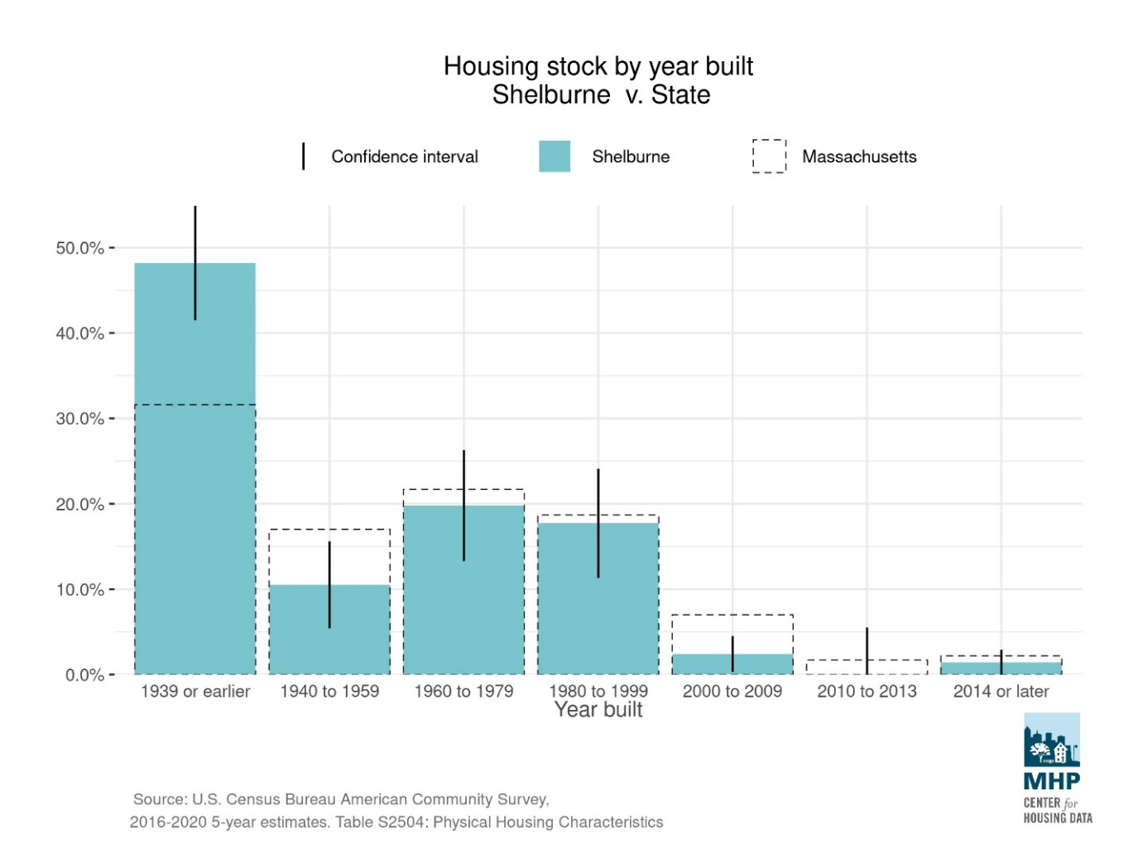

#### An aging community

Shelburne’s population is one of the oldest in Franklin County. The median age in 2020 was 56. The number of school age children has declined by more than one-third since 2000, which has contributed to lower school enrollment in the Mohawk Trail Regional School District. The number of residents aged 65-84 has almost doubled in the last 10 years. One third of Shelburne residents are over the age of 65. As the baby boomer generation continues to age, the senior population in Shelburne is expected to continue to grow over the next decade.

Source: 2000 and 2010 U.S. Decennial Census; 2020 2020 Decennial Census PL-94 Redistricting data.

#### Household incomes and housing affordability

A high percentage of households in Shelburne could potentially benefit from housing or programs created or supported by Community Preservation Act funds. More than 55% of households in Shelburne have incomes below 100% of the Area Median Income. Based on the estimates in the figure below, the largest income category group that could benefit from affordable housing efforts are extremely low income households (approximately 24% of Shelburne households), followed by low income households (21% of Shelburne households).

Data source: U.S. Census American Community Survey 5-year estimates 2018-2022

Buying a home is increasingly becoming out of reach, even to those with moderate income levels. Over the previous eight years, median single-family home prices in Shelburne has increased from approximately $225,000 in 2015 to $400,000 in 2022, a 78% increase. Based on the years 2018 and 2022, only 10-22 homes have been sold per year. This number may be especially low during a period of high interest rates and home sales being flat around the country.

Data source: MA Department of Revenue, Division of Local Services

#### Housing types

A wide variety of housing types enables people of different means and at different stages of life to have viable housing options within a community. Different housing types allow for greater density in places where it is most appropriate, such as areas of town that are served by municipal water and sewer, within walking distance to schools and village centers, and along the Franklin Regional Transit Authority (FRTA) bus route.

Shelburne’s housing is mostly single-family detached housing, with some two-family (duplexes) and 3-4 unit apartment buildings. The graph below was generated using Massachusetts Housing Partnership’s DataTown, and compares Shelburne with that of Massachusetts.

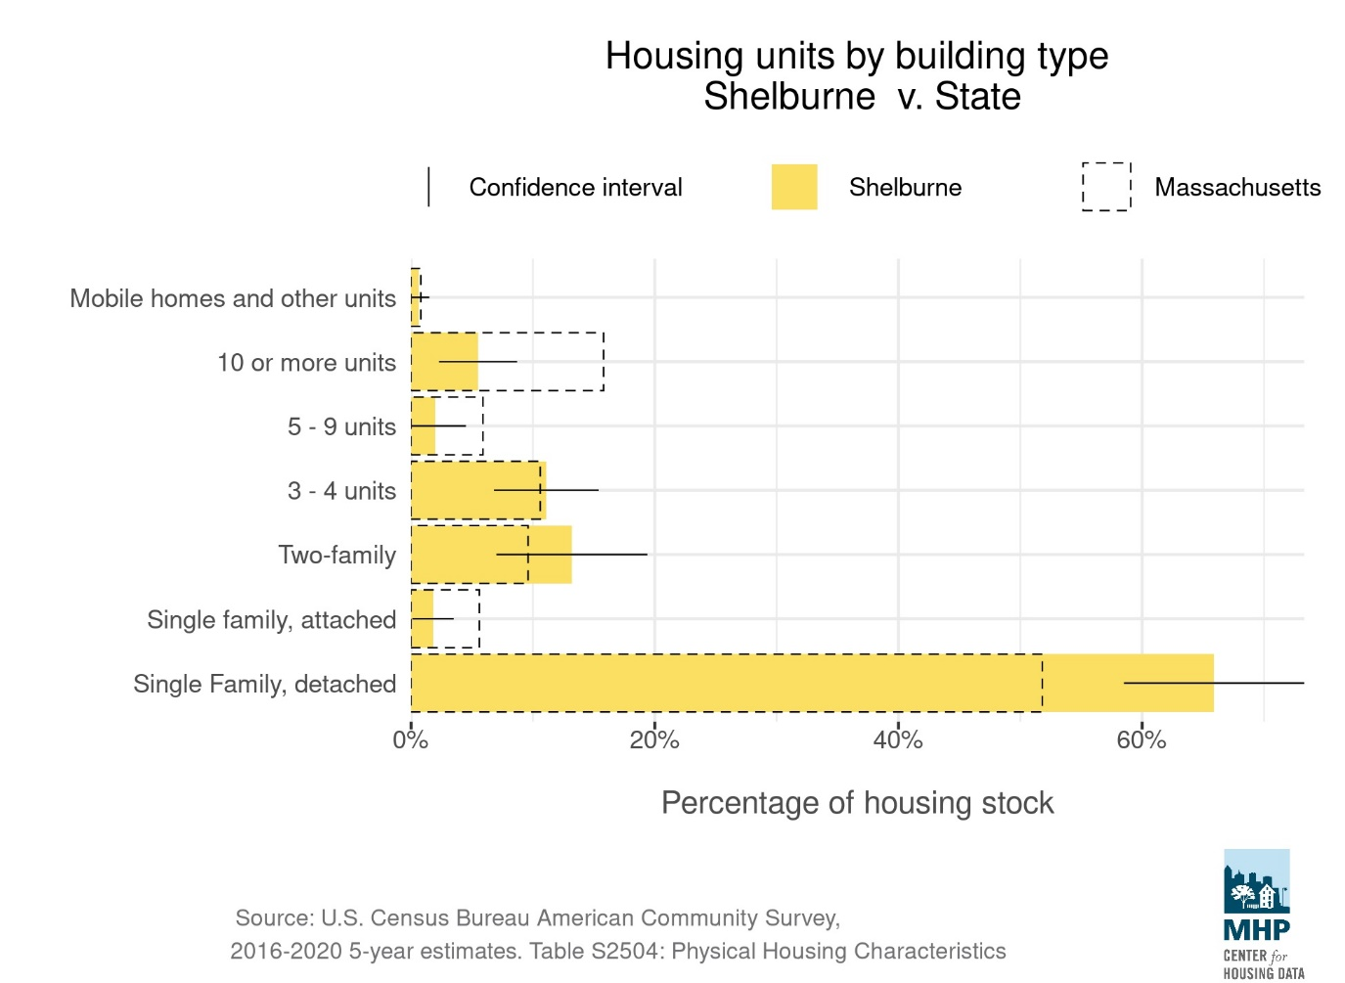

#### Shelburne’s inventory of affordable housing

Shelburne has 46 units of affordable housing at Highland Village for those ages 60 or for persons with disabilities. Highland Village is now owned and managed by the Franklin County Regional Housing and Rehabilitation Authority (HRA). The MA Executive Office of Housing and Livable Communities (EOHLC) counts those units when they calculate a percentage of Subsidized Housing of 4.8% in Shelburne.[13] Under M.G.L. Chapter 40B, towns have less than the guideline of 10% subsidized housing are vulnerable to affordable housing developments that do not have to follow local zoning rules and other local rules.

Housing Needs

Shelburne’s 2018 Housing Plan identified the following types of housing needed in town.

Senior Housing: Though Highland Village offers 46 units of affordable senior housing in town, when the 2018 Housing Plan was written, there was a waiting list of 34 households. Additionally, seniors now make up one-third of the town’s population, and that is likely to increase.

Housing for First-Time Homebuyers: Starter homes for first-time homebuyers was the top housing need identified in a community survey in 2017 that was part of the Housing Plan work. Single family home sale prices have increased by 78% in the previous eight years, approaching or surpassing a median of $400,000, which is unaffordable for typical incomes in Franklin County. Few homeowners are under the age of 35 in Shelburne, which suggests that prices are too high for most young people who are looking to purchase their first home.

Rental Housing: Shelburne continues to have low availability of apartment rentals. Demand is consistently higher than supply, which has likely also been impacted by the recent rise of housing being used for short term rentals in town. The 2018 Housing Plan identified that additional rental housing is needed for a range of income levels to serve seniors, families, young professionals, and others who either cannot afford to own their own home or who do not wish to own a home.

Housing for Families: The 2018 Housing Plan identified an interest in supporting housing for families with children to help increase school enrollment and support a stable population into the future.

Housing for Persons with Disabilities: The 2018 Housing Plan stated that 14% of Shelburne’s population has a disability of some type, and this percentage is higher among seniors. As the population of seniors increases, additional residents will need accessible housing. Of Highland Villages 46 units, only three are built to be accessible for those with disabilities.

CPA Eligibility

CPA funds may be spent on the **acquisition, creation, preservation,** and **support** of **community housing**, and for the **rehabilitation** or **restoration** of community housing that has been acquired or created using CPA funds. As Shelburne is a new CPA community, no housing has yet been acquired or created using CPA funds. The CPA requires that whenever possible, preference be given to the adaptive reuse of existing buildings or construction of new buildings on previously developed sites.[14]

**Community housing** is defined in the CPA legislation as low and moderate income housing for individuals and families, including low or moderate income senior housing**.**

**Preservation** is defined as “protection of personal or real property from injury, harm or destruction, but not including maintenance.”

**Support** is defined as “programs that provide grants, loans, rental assistance, security deposits, interest-rate write-downs or other forms of assistance directly to individuals and families who are eligible for community housing.”

The creation or preservation of community housing under the CPA includes low- and moderate- income housing for individuals, families and senior citizens. These terms are defined as follows:

Low-income Housing – Housing for those persons and families whose annual income is less than 80% of the area-wide median income (AMI) as determined by the U.S. Department of Housing and Urban Development (HUD).

Moderate-income Housing - Housing for those persons and families whose annual income is less than 100% of the AMI as determined by HUD.

Low- or moderate-income Senior Housing - Housing for those persons having reached the age of 60 or over who would qualify for low- or moderate-income housing.

Housing developed with CPA funds may be offered to those persons and families whose annual income is less than 100% AMI (moderate income). Communities may choose, however, to limit certain housing units created with CPA funds to those persons and families earning less than 80% of the AMI (low income). This allows communities to include these units on the Massachusetts Department of Housing and Community Development’s (DHCD) Subsidized Housing Inventory (SHI) in order to reach the goal of 10% affordable housing established in M.G.L. Chapter 40B.

Affordability limits for Franklin County by household size are shown below.

|  |  |  |  |  |
| --- | --- | --- | --- | --- |
| Household Size and FY2024 Income Limits for Franklin County | | | | |
| Low income (80% AMI) | **1** $52,136 | **2** $59,584 | **3** $67,032 | **4** $74,480 |
| Moderate income (100% AMI) | **1** $65,170 | **2** $74,480 | **3** $83,790 | **4** $93,100 |

Source: <https://www.communitypreservation.org/allowable-uses#anchor_housing>

The CPA Statute also allows CPA funds to be appropriated to a Municipal Affordable Housing Trust (MGL c.44 s.55C). Shelburne does not have an Affordable Housing Trust, but may consider setting one up in the future. Massachusetts Housing Partnership (MHP) provides technical assistance to towns looking into establishing a Municipal Affordable Housing Trust.

Housing Goals

The CPC has identified the following evaluation criteria for community housing proposals. The CPC will support community housing proposals that meet one or more of the following objectives:

* Actively pursue and fund a variety of community housing initiatives to increase housing choice and enhance Shelburne’s diversity and vibrancy.
* Promote affordable, safe, ADA-accessible and energy efficient rental opportunities.
* Increase options for first-time and first-generation homebuyers.
* Support affordable housing for all ages, abilities and income levels.
* Support the creation of affordable units that count on the state’s Subsidized Housing Inventory, per MGL c.40B, by funding context-sensitive developments.
* Encourage the inventive reuse of existing buildings or new buildings on previously developed sites.

1. The Community Preservation Coalition was formed in the 1990’s with the goal of passing the CPA law and now helps municipalities understand, adopt and implement CPA, and advocates for CPA at the state level.
2. Environmental Justice communities are determined based on U.S. Census blocks, and the Shelburne Falls portion of Shelburne is one Census block.
3. Hazards can include but is not limited to exposure to chemical or biological contaminants or to natural hazards such as flooding.
4. The Community Preservation Coalition’s website gives some guidance on this issue at <https://www.communitypreservation.org/private-projects>.
5. Shelburne does not have a town Historic Commission. As explained in Section 6 of this Plan, the Community Preservation Committee will determine historic significance for projects involving anything not listed on the State Register.
6. Massachusetts Department of Revenue, Data Analytics and Resources Bureau, Average Single Family Tax Bill. Online at: <https://dlsgateway.dor.state.ma.us/reports/rdPage.aspx?rdReport=AverageSingleTaxBill.SingleFamTaxBill_wRange>
7. Massachusetts Department of Revenue, Data Analytics and Resources Bureau, Tax Rates by Class. Online at: <https://dlsgateway.dor.state.ma.us/reports/rdPage.aspx?rdReport=PropertyTaxInformation.taxratesbyclass.taxratesbyclass_main>
8. As Shelburne is a new CPA community, the second part of this sentence does not yet apply to Shelburne.
9. <https://www.townofshelburne.com/files/Buckland-Shelburne_MasterPlan_1999.pdf>
10. <https://frcog.org/wp-content/uploads/2014/05/MTPLAN.05-historic.final_.pdf>
11. The difference between Local and National Historic Districts is explained in this fact sheet from the MA Secretary of State’s office: <https://www.sec.state.ma.us/mhc/mhcpdf/difference.pdf>
12. More information on these standards is online at <https://www.communitypreservation.org/SOI-standards>.
13. <https://www.mass.gov/info-details/subsidized-housing-inventory-shi>
14. Community Preservation Coalition, <https://www.communitypreservation.org/allowable-uses>