**ARTICLE 35:** To see if the Town will **vote to adopt a new Section 13.4 Common Driveways as follows,** or take any action relative thereto:

**Section 13.4 Common Driveways:** The Planning Board may authorize a special permit allowing a Minor Street to be used as a common driveway for a group of subdivision lots (regular or Open Space Development) or ANR lots as long as each of the lots served by the common driveway meets the frontage and area requirements for a building lot.

13.4.1. Common driveways shall meet the design criteria for a Minor Street as set forth in the Town of Shelburne Subdivision Regulations.

13.4.2. The common driveway shall be designed before a building permit for a new dwelling is approved and the common driveway construction shall be completed before any occupancy or use of the premises is permitted.

13.4.3. Common driveways shall, if serving more than two dwelling units, be named as a “private way” (Example: “Smith Way, A Private Way”) with a sign placed in plain view from its intersection with a public way. Said sign shall be consistent with Town street signs currently in use at the time of application, paid for by the applicant, and the name of the new Private Way shall be authorized by the Select Board following consultation with all applicable Town officials.

***Amendment was passed (refer to color text attached for amendment to article 35) by Majority voice vote***

***Article then approved by 2/3 Majority Vote YES 107 NO 7 Abstain 3***

**ARTICLE 36:** To see if the Town will **vote to adopt the following revisions to Section 2.28 Minor Street, Section 2.20 Frontage, and add a new definition of Street with section number to be assigned according to alphabetical placement in Section 2. Definitions,** or take any action relative thereto**:**

**Modify Section 2.28 Minor Street – changes are in bold typeface:**

**Section 2.28 Minor Street:** A street that provides vehicular access to and from a public street **~~to~~**which: (a) is no longer than 750 feet; (b) serves **~~up to~~** no more than five lots which would otherwise be required to have their own access and frontage; (c) is jointly owned in fee or as an easement as specified on the deeds of the owners of the properties to which it provides access; (d) the maintenance of which is arranged between the joint owners/users as specified in deeded covenants; **and (c) lies entirely within some combination of:**

1. **the lots being served:**
2. **the Open Space within an Open Space Development;**
3. **a deeded right of way.**

**Replace the existing definition of Frontage that reads as follows, with a New Definition of Frontage:**

*Section 2.20 Frontage: that boundary from which primary access to the lot is gained. Access shall be gained only from a public way or way accepted under the Town of Shelburne Subdivision Regulations. The portion of a lot fronting on a discontinued road, or a road which is not continuously constructed to a point beyond the border of the subject lot, does not constitute frontage for purposes of Approval-Not-Required (ANR)Plans****.***

Section 2.20 Frontage: the boundary where a lot meets the right-of-way of a street (as defined in Section 2.___ of these Bylaws), measured as the unbroken distance entirely in the Town of Shelburne between the sidelines of the lot measured along the street line, through which the primary means of “vital access” (as contemplated by M.G.L. Chapter 41, Section 81M, as interpreted by court cases from time to time) from the street to the lot may be gained. “Vital access” means that the access to the lot is unimpeded by:

1. Wetlands, unless a wetlands crossing has been approved by the Town of Shelburne Conservation Commission; or
2. Topography or other natural barrier which would make direct access to the lot from the street, while possible, very difficult or expensive unless the Planning Board has determined:
3. that adequate access to the lot from a public way exists through a deeded right of way with a minimum width of thirty (30) feet which meets the definition of a “Minor Street” in Section 2. ___ of these Bylaws (the Planning Board may grant a waiver of the width requirement if it determines that the tests set forth in subsection (2), below, have been met.); AND
4. after consultation with and written approval of the Selectmen, Highway Superintendent, Police Department and the Town of Shelburne Fire Department or the Shelburne Falls Fire and Water District (as applicable), that the deeded right of way will, in fact, (a) be adequate to provide for the needs of safe vehicular traffic in relation to the proposed use of the lot including satisfactory public safety access, and (b) for installation of municipal services, if applicable, which will serve such land the buildings erected or to be erected thereon.

**Adopt a new definition of Street with the Section number to be assigned to maintain alphabetical order, as follows:**

Section 2. ____ Street: for the purpose of determining frontage only, a way located in the Town of Shelburne which is:

1. Certified by the Town Clerk, to be a public way or is maintained and used as a public way; OR
2. A private way shown on a definitive plan of a subdivision approved by the Planning Board, actually built; OR
3. A way in existence on September 6, 1972, when the Subdivision Control Law came into effect in the Town of Shelburne, which the Planning Board has determined will provide adequate frontage after considering, at a minimum, the following:
4. Is the right-of-way at least 30 feet wide and of reasonable horizontal alignment?
5. Does the existing horizontal and vertical alignment of the roadway provide safe visibility?
6. Is the roadway at least sixteen (16) feet wide with an additional two (2) feet of shoulder on each side (20 feet wide in total) to provide space for snow removal.
7. If the road could ever service more than ten dwelling units, is it bituminous surfaced or have provisions been made for such surfacing without cost to the Town?
8. Have provisions been made for public utilities without cost to the Town?
9. Is the grade less than or equal to 10%?
10. Any other requirement the Planning Board deems necessary to assure that the roadway has sufficient grade, width, and depth to assure safe vehicular traffic including emergency vehicles.
11. The Board will not normally find a way in existence when the subdivision control law became effective in the Town of Shelburne to provide adequate frontage unless it meets the above standards. However, the Board may waive strict compliance with a standard upon its determination, following consultation with the Selectmen, Highway Superintendent, Police Chief, and Town of Shelburne Fire Chief or the Fire Chief of the Shelburne Falls Fire and Water District, as appropriate, that the way will, in fact, be adequate to provide for the needs of vehicular traffic lot, including satisfactory public safety access, in relation to the proposed use of the land abutting thereon or served thereby, and for installation of municipal services, if applicable, to serve such land and the buildings erected or to be erected thereon.

***Amendment was passed ( refer to color text attached for amendment to article 36) by Majority voice vote***

***Amended Article Failed to attain a 2/3 Majority 48 yes 38 no 14 abstain***

**ARTICLE 37:** To see if the Town will **vote to adopt a new Section 5.2.1 Flag Lots as follows**, or take any action relative thereto:

Section 5.2.1. FLAG LOTS

5.2.1.1 Purpose. The purposes of this section, in addition to the general purposes of these Zoning Bylaws, are to encourage the efficient use of land resources in new residential development, to preserve the scenic qualities of the Town, and to protect or enhance the value of properties in the Town by enabling landowners to create appropriate patterns of land ownership, use, and development, subject to public review and approval.

5.2.1.2. Individual lots that do not have the required amount of street frontage set forth in the Dimensions Table, above, may be permitted if the Planning Board determines:

1. That such a lot will encourage the efficient use of land resources in residential development, preserve the scenic qualities of the Town, and/or to protect or enhance the value of properties in the Town, AND
2. That such a lot will not:
3. Have a substantial adverse environmental impact on groundwater quality, wetlands, significant wildlife habitat, prime farmland, or other environmentally-sensitive resources; or
4. Remove destroy or obstruct prominent natural features and views, or
5. Remove, destroy, or irrevocably alter significant historical, archeological, and/or cultural resources.

5.2.1.3 Any such lot that is included within a Definitive Subdivision Plan may be allowed by the Planning Board provided the lot meets all of the requirements of Section 5.2.1.5 through Section 5.2.1.14.

5.2.1.4 Any such lot that is not part of an Approved Definitive Subdivision Plan, may be allowed by the Planning Board as a part of a “Approval Not Required” plan or as a stand-alone plan recognizing an existing parcel of land as an approved flag lot provided that the lot meets all of the requirements of Section 5.2.1.5 through Section 5.2.1.14.

5.2.1.5. The area of each flag lot, exclusive of the access strip, shall be at least double the minimum lot area normally required for the district.

5.2.1.6 Each lot shall have an access strip with a minimum street frontage of forty (40) feet, a minimum width of forty (40) feet at any point between the street and the principal building, and a maximum length of four hundred (400) feet, after which distance the access strip shall end and the building area of the lot shall begin.

5.2.1.7. The Planning Board may permit an access strip longer than 400 feet, if the Planning Board determines, after receiving the written approval of the Select Board, Highway Department, Police Chief, and ~~relevant~~ Fire Chief with jurisdiction, that the proposed access strip way will adequately serve the access and public service needs of the lot.

5.2.1.8. The width of that portion of the lot where the principal building is to be constructed, known as the building area, shall equal or exceed the distance normally required for street frontage in the district. Said width shall be measured along the nearest continuous “street-ward” boundary of the building area of the lot.

5.2.1.9. That portion of a flag lot within which the principal building is to be located shall be considered the building area. The building area of a flag lot shall be capable of containing a circle whose diameter is equal to or greater than the minimum standard street frontage required in the district where the flag lot has its frontage, without any portion of said circle falling outside of the property.

5.2.1.10. There shall be no more than two flag lots access strips adjacent to each other at the street line.

5.2.1.11. If more than one flag lot access strips adjacent to one another and are under common ownership at the time of their formation, they shall be served by one shared curb cut and a common driveway which meets the requirements of a Minor Street, as defined in Section 2.28 of this Zoning Bylaw.

5.2.1.12. The grade, length and location of flag lot access driveways shall be of suitable construction, in the opinion of the Planning Board, for the access and, where applicable, the turnaround for vehicles, including moving vans, ambulances, fire and police.

5.2.1.13. There shall be no more than three (3) flag lots created from any land identified, according to the records of the Assessor’s office, as a single parcel of land as of the effective date of this Section 5.2.1 unless such flag lots are proposed as part of a Definitive Subdivision.

5.2.1.14. Any plan showing a proposed flag lot shall have the following notation:

*“In approving this plan, the Shelburne Planning Board has determined that the flag lot(s) shown on this plan:*

1. *will encourage the efficient use of land resources in residential development, preserve the scenic qualities of the Town, and/or to protect or enhance the value of properties in the Town, AND*
2. *that such lot(s) will not:*
3. *have a substantial adverse environmental impact on groundwater quality, wetlands, significant wildlife habitat, prime farmland, or other environmentally-sensitive resources; or*
4. *remove, destroy or obstruct prominent natural features and views, or*
5. *remove, destroy, or irrevocably alter significant, historical, archeological and/or cultural resources.”*

**Majority Voted to Pass Over (Voice Vote)**

**ARTICLE 38:** To see if the Town will **vote to adopt the following revisions to Section 5.1 Dimensional Requirements, add a new Section 5.4 Exception to Dimensional Requirements for Side and Rear Setbacks, and revise Section 10 Non-Conforming Uses, Structures and Lots**, or take any action relative thereto—changes are in bold typeface:

**Modify Section 5.1 to read as follows:**

Section 5.1 DIMENSIONAL REQUIREMENTS: a structure shall be erected or used, or a lot shall be changed in size or shape, only in conformity with the following schedule: ***exceptions are described in Section 5.4 and exemptions are described in Section 1.0.1.1.***

**Insert a new Section 5.4 to read as follows”**

**SECTION 5.4. EXCEPTION TO DIMENSIONAL REQUIREMENTS FOR SIDE AND REAR SETBACKS**

5.4.1 The ZBA may reduce, by Special Permit, the dimensional requirements for side and rear yards related to a new building and/or driveway setbacks provided that the Zoning Board of Appeals makes a determination that the proposed structure is consistent in scale or setback with the structures in abutting parcels and the immediate neighborhood. The Zoning Board of Appeals shall make the following determinations before granting an exception:

1. The ZBA shall specifically determine that the reduced dimensional requirement for a side or rear yard will have no adverse effect on adjacent properties or historic structures.
2. The ZBA shall specifically determine that the reduced dimensional requirement for a side or rear yard will not be a detriment to the public good and will not substantially undermine the intent of the Shelburne Zoning Bylaws.

5.4.2 The applicant shall file, with the application for a Special Permit, a detailed plan drawn to scale of the property that shows the lot lines and dimensions of the property, the dimensional setbacks requirements as they currently exist for side or rear yards, the proposed location of the structure, and any proposed reduction to the dimensional requirements of the Zoning Bylaws. The ZBA may grant any setback reduction where the boundary or lot line from which setback relief is requested has been established, by survey or other recognized documentation from which the ZBA can readily determine the location of the lot lines.

**Modify Section 10.0 Non-Conforming Uses to read as follows – changes are in bold typeface:**

SECTION 10.0 NON-CONFORMING USES***,* STRUCTURES AND LOTS**

10.1 GENERAL **~~REGULATIONS~~**

The lawful use of any structure or land existing at the time of the enactment or subsequent amendment of this by-law may be continued even through such structure or use does not conform with this by-law***. [Note: this is formerly 10.1.1]***

10.1.1 **EXEMPTIONS: Exemptions shall be as follows:**

1. **A structure lawfully begun under a building permit or special permit issued before the first publication of notice of the required public hearing by the ~~Planning Board~~ Zoning Board of Appeals on the applicable zoning bylaw or amendment.**
2. **Any alteration, reconstruction, extension or structural change to a one-family or two-family structure, provided that this does not increase the nonconforming nature of such structure. In the following circumstances an alteration, reconstruction, extension or structural change to a one-family or two-family structure shall not be considered an increase in the nonconforming nature of the structure and shall be permitted as of right:**
3. **An alteration, reconstruction, extension or structural change which complies with all current dimensional requirements.**
4. **An alteration, reconstruction, extension or structural change to the side, rear, or face of the one or two-family structure which encroaches upon current setback requirements, as specified in Section 5.2 Dimensional Schedule, where an alteration, reconstruction, extension or structural change will not encroach upon such area to a distance greater than the existing structure.**
5. **Any alteration, reconstruction, extension or structural change to a one-family or two-family structure which will increase the existing nonconformity by further encroaching on required setback requirements or exceeding the maximum lot coverage or building height as specified in Section 5.2 Dimensional Schedule, may be authorized by special permit from the ZBA upon a finding that such alteration, reconstruction, extension or structural change shall not be more detrimental than the existing nonconforming structure to the neighborhood.**
6. **The expansion or reconstruction of existing structures for the primary purpose of agriculture, horticulture or floriculture**
7. **Nonconforming lots of record and lots shown on a plan endorsed by the Planning Board under the Subdivision Control Laws are exempt from the provisions of this chapter to the extent and as provided in MGL c. 40A, Section 6.**
8. **In the VR district, a property with one- or two-family residential structures and a detached accessory dwelling unit, built in conformity with zoning bylaws in effect at the time of construction but not in conformity with setbacks in Section 5.2, may be subdivided into two separate lots through an ANR application if those lots are in compliance with lot size and frontage in effect at the time of the ANR submittal to the Planning Board. See Section 10.1.1 and Section 23.**

**[Note replace the existing Section 10.1.2 with a new Section 10.1.2]**

*Current Section 10.1.2 ALTERATION: no non-conforming use shall be changed, moved or extended and no non-conforming building or structure shall be constructed or substantially altered or enlarged except where alteration, reconstruction, extension or structural change to a single or two family residential structure does not increase the non-conforming nature of said structure or except pre-existing non-conforming structures or uses may be extended or altered provided that no such extension or alteration shall be permitted unless there is a finding by the ZBA that such change, extension or alteration shall not be substantially more detrimental than the existing non-conforming use to the neighborhood. This section shall not apply to billboards, signs and other advertising devices subject to the provisions of Sections 29 through 22 inclusive of Chapter 93 of the Massachusetts General laws.*

10.1.2 ALTERATION: The Zoning Board of Appeals may authorize by special permit any extension, alteration or reconstruction of a nonconforming structure to provide for its use for a substantially different purpose or for the same purpose in a substantially different manner or to a substantially greater extent, provided that no such extension, alteration, reconstruction or change in use shall be permitted unless the Zoning Board of Appeals finds that:

1. Such change, extension or alteration shall not be substantially more detrimental than the existing nonconforming use to the neighborhood.
2. Such extended, altered or reconstructed structure or changed use shall not be in greater nonconformity with open space, setbacks and off-street parking requirements. See Section 11.

***Note: the following Sections 10.1.3 through 10.1.6 remain the same.***

**10.1.3 RESTORATION**: In the event that a non-conforming building is destroyed by fire or other cause, the same may be reconstructed or repaired on the same location for the same or less non-conforming use provided the new building may be equal in appearance and character to the original structure.

**10.1.4 LIMITATION ON RESTORATION**: In the event that any non-conforming building is damaged by fire, explosion or other cause, restoration work must be undertaken within two years of the date damage is inflicted unless, upon application to the Zoning Boards of Appeals, it can be shown that restoration within the time limit is impossible in which case extension of time may be granted.

**10.1.5 CHANGES:** once changed to a conforming use, no structure or land shall be permitted to revert to a non-conforming use.

**10.1.6 ABANDONMENT**: a non-conforming use or structure, which has been abandoned or not used for more than two years shall not be re-established and any future use shall conform with this by-law.

***Majority Voted to Pass Over (Voice Vote)***

**ARTICLE 39:** To see if the Town will **vote to adopt a revised zoning map dividing the Village Residential district into two districts VR-1 and VR-2,** or take any action relative thereto**:**

*[See attached revised Draft Shelburne Zoning Map – Page 20, attachment A]*

***(Refer to color text pertaining to Article 39)***

***Article was defeated by a 2/3 Majority Vote 57 YES 33 NO 9 ABSTAIN***

**ARTICLE 40:** To see if the Town **will vote to adopt the following revisions to Section 5.2 of the Shelburne Zoning Bylaw Dimensional Schedule, and related changes to Section 3.1 Establishment of Districts, Section 4.2.7 Table of Use Codes, Section 4.3 Table of Use Regulations, Section 7.0 Home-Based Business. and Section 11.2.2 Parking Requirements – Village Residential District,** or take any action relative thereto:

**Revise the Dimensional Schedule for Districts VR-1 and VR-2 – changes are underlined and in bold typeface.**

5.2 DIMENSIONAL SCHEDULE **e, f**

|  |  |  |  |  |  |  |
| --- | --- | --- | --- | --- | --- | --- |
|  | **RA** | **VR-1g** | **VR-2** | **VCg, i** | **C** | **I** |
| Minimum Lot Area (sq ft) | 86,000 | **~~20,000~~** 8,000a **~~(a)~~** | **20,000a** | **~~20,000~~** 5,000 | 86,000 | 86,000 |
| Minimum Lot Frontage (ft) | 250 | **~~100~~** 50a **~~(a)~~** | **100a** | **~~100~~** 50 | 250 | 250 |
| Front Yard Setback (ft) | 25 | 20b **~~(b)~~** | **20b** | 20b **~~(b)~~** | 30 | 50 |
| Side Yard Setbacks (ft)**c** **~~(c)~~** | 20 | 10 | **10** | 10 | 30 | 30 |
| Rear Yard Setback (ft) | 20 | 20 | **20** | 20 | 30 | 30 |
| Max Height of Buildings (ft)**d ~~(d)~~** | 35 | 35 | **35** | 35 | 35 | 35 |
| **Maximum Lot Coverageh** | **20%** | **50%** | **25%** | **80%** |  |  |

**Footnotes to Dimensional Schedule:**

(a)If public water or public sewer is not available increase the lot size to 40,000 square feet and

lot frontage to 150 feet;

(b) However, the front yard dimension may be determined by the setback of existing structures

on adjacent parcels where those setbacks are less than the minimum front yard dimension

required by this bylaw;

(c) **Except for the VR district**, ~~N~~ new driveways must be set back to meet the Side Yard requirement

for each district unless a **Special Permit** ~~variance~~ is granted by the Zoning Board of Appeals (ZBA); **in the VR District, a new driveway may be sited within a setback as long as it is at least 10 feet away from any residential structure on an abutting property or unless a special permit has been granted by the ZBA**.

(d) The ZBA may grant a Special Permit for structures higher than 35 feet where the ZBA determines that said higher structure is compatible with the surrounding structures and does not unreasonably interfere with existing structures.

(e) Setbacks and height restrictions for a PUWES are described in Section 17.5.2.

(f) Setbacks and height restrictions for a LSSI are described in Section 18.5.1.

(g) **Certain dimensional requirements in the VR-1 and VC districts may be adjusted by**

**Special Permit according to Section 23.0 Affordable Housing Incentive Zoning.**

**(h) Lot coverage shall mean all impervious surfaces including structures and paved surfaces.**

**(i) To maintain the existing historic urban pattern in downtown Shelburne, parcels with frontage on Bridge Street in the VC district, except those used solely for surface parking, shall have no maximum lot coverage requirement, and no minimum front, side, or rear yard setback requirements, except when abutting a residential use, in which case the minimum setback from the residential property line shall be 10 feet.**

**Revise Sections 3, 4, 7, and 11 to clarify Village Residential district language recognizing both VR-1 and VR-2**

**SECTION 3.0 – ESTABLISHMENT OF DISTRICTS**

3.1 For the purposes of this by-law, the Town of Shelburne is hereby divided into the following types of districts:

**3.1.1** Rural Residential/ Agricultural (RA),

**3.1.2** Village Residential – 1 (VR**-1),**

3.1.3 Village Residential – 2 (VR-2),

**3.1.4~~3~~** Village Commercial (VC),

**3.1.5~~4~~** Commercial (C),

**3.1.6~~5~~** Industrial (I).

**SECTION 4.2 TABLE OF USE CODES:**

**4.2.5** RA = Rural Residential/Agricultural District

**4.2.6** VR-1 = Village Residential – 1 District

**4.2.7** VR-2 = Village Residential – 2 District

**4.2.8~~7~~** VC = Village Commercial District

**4.2.9~~8~~** C = Commercial District

**4.2.10~~9~~** I = Industrial District

**SECTION 4.3 TABLE OF USE REGULATIONS**: *[Note: the only change to Section 4.3 is the column heading]*

RA **VR-1/VR-2** VC C I

**SECTION 7.0 – HOME-BASED BUSINESS**

**7.4** A home-based business to be operated within the Rural Residential/Agricultural (RA) or Village Residential **(VR-1 and VR-2)** Districts shall require a Special Permit from the Zoning Board of Appeals.

**7.5** The Building Inspector may grant approval for home-based businesses in the Rural/Residential Agricultural (RA) or Village Residential (**VR-1 and VR-2)** Districts, provided that the Building Inspector has received adequate information from the applicant to make a determination that all of the following criteria are satisfied:

**SECTION 11.0 PARKING REQUIREMENTS**

11.2.2 Village Residential District**s**

It shall be the policy of the Town to preserve the existing character of the Village Residential District**s** to the extent reasonably possible by maintaining the existing types of residential structure in the District**s** while increasing the number of residential dwelling units.

***Unanimous Vote to Pass Over (Voice Vote)***

**ARTICLE 41:** To see if the Town will **vote to adopt changes to Section 4.3 relative to Commercial Greenhouses**, or take any actions relative thereto:

*Current Shelburne Zoning Bylaw*

**Agricultural & Recreational Uses RA VR VC C I**

Commercial Greenhouse on a lot 5 acres or greater Y **SP**  **SP** Y Y

*Proposed revisions*

**Agricultural & Recreational Uses RA VR VC C I**

Commercial Greenhouse on a lot 5 acres or greater Y  **Y**  **Y** Y Y

*[Note: If the VR District is divided into VR-1 and VR-2, Commercial Greenhouse on a lot 5 acres or greater will be allowed by right in both VR districts.]*

***Majority Vote to Pass Over 91 YES 0 NO 1 ABSTAIN***

**ARTICLE 42:** To see if the Town will **vote to adopt a new Section 23. Affordable Housing Incentive Zoning with related revisions to Section 2. Definitions, as follows** or take any action relative thereto**:**

**SECTION 23.0 Affordable Housing Incentive Zoning**

23.1 Purpose and Intent: The purpose of this bylaw is to:

1. Assist the Town in creating units eligible for the Commonwealth’s Ch. 40B Subsidized Housing Inventory (SHI).
2. Address the need for affordable housing documented in the Shelburne Housing Plan, effective February 6, 2018, as updated.
3. Encourage developers to include affordable housing in residential and mixed use development and redevelopment.
4. Encourage residential infill development within the village zoning districts that is consistent with the character of the surrounding neighborhood.
5. Encourage affordable housing in close proximity to jobs, schools, shopping, services, and transit, and in areas served by the water and sewer districts.

23.2 Applicability: In the Village Commercial (VC) Zoning District the Zoning Board of Appeals may issue a Special Permit, in accordance with Section 6.0 Special Permits, and in the Village Residential-1 (VR-1) Zoning District, the Planning Board may issue a Special Permit, in accordance with Section 6.0 Special Permits, for one or more of the following in exchange for the provision of affordable housing units in a development:

1. In the Village Residential-1 (VR-1) district, the minimum lot area may be reduced to 5,000 square feet, and the maximum lot coverage may be increased to 60% for the construction of either one affordable single-family home or one affordable two-family home (both units in a two-family home shall be affordable) on such a lot.
2. In the Village Commercial (VC) district, multi-family development within a new structure or a non-historic structure may include up to eight (8) dwelling units, provided a minimum of 25% of the units in the development are affordable. When the requirement results in a fraction of a dwelling unit, the number of total affordable housing units shall be rounded up to the next whole number where the fractional portion is equal to 0.5 or greater, and shall be rounded down to the next whole number where the fractional portion is less than 0.5, provided that the overall percent of affordable units in the development is at least 25%.
3. In the Village Commercial (VC) and Village Residential-1 (VR-1) districts, affordable single-family homes may have a minimum side yard setback of zero (0) feet on one side, to allow for a zero-lot line development. Zero-lot line developments shall meet the following requirements:
   1. All lots proposed for zero-lot line development shall be under the control of the same property owner at the time the zero-lot line development is proposed.
   2. The two abutting lots shall each have a minimum area of 4,000 square feet and a minimum frontage of 40 feet and shall meet all other setback and dimensional requirements of the zoning district.
   3. A shared wall shall be required along the zero-lot line between the two single-family homes with a zero-lot line; provided that said shared wall constitutes a “Fire Wall” as defined by the Massachusetts State Building Code CMR 780, or provided that residential fire sprinkler system protection is installed and maintained in both homes in accordance with the current revision of National Fire Protection Association standards for such systems.
   4. All units within a zero-lot line development shall be affordable.
   5. Accessory Apartments shall not be permitted in a zero-lot line development.

23.3 Requirements:

1. The affordable housing units created through this Bylaw shall qualify as Local Action Units through the Department of Housing and Community Development’s (DHCD) Local Initiative Program, or through other affordable housing programs that result in units that are eligible for listing on the Ch. 40B Subsidized Housing Inventory. The Applicant shall be responsible for preparing and complying with any documentation that may be required by DHCD to qualify affordable units for listing on the Chapter 40B Subsidized Housing Inventory.
2. All affordable units constructed or rehabilitated under this Bylaw shall be situated within the development so as to be integrated with any market-rate units in the development and shall, on average, be no less accessible to public amenities as the market-rate units. The Special Permit Granting Authority in its sole discretion makes the final determination of the suitability of the siting of the affordable units.
3. Projects containing affordable units shall meet the minimum design and construction standards set forth by the Massachusetts Department of Housing and Community Development Local Initiative Program (LIP) or other applicable affordable housing program that result in affordable units eligible for inclusion on the Ch. 40B Subsidized Housing Inventory. In addition, all housing units (market rate and affordable units) created through this bylaw shall adhere to the design guidelines in accordance with Section 24.0 Village Design Guidelines for Residential Structures.
4. Development proposing a mix of affordable and market rate units shall submit a phasing plan as part of the Special Permit application that provides for the timely and integrated development of the affordable housing units as the development project is built out. The phasing plan shall provide for the development of the affordable housing units concurrently with the market rate units in order to ensure a minimum of 25% affordable units are provided. Building permits shall be issued for the development project based upon the phasing plan. The phasing plan may be adjusted if approved by the Special Permit Granting Authority in order to account for the different financing and funding environment, economies of scale, and infrastructure needs applicable to development of the market rate and the affordable units.

23.4 Submission Requirements: The development of any project under this bylaw (Section 23.0 Affordable Housing Incentive Zoning) shall require the grant of a Special Permit from the Planning Board for projects proposed in Village Residential-1 (VR-1) District, and from the Zoning Board of Appeals for projects proposed in the Village Commercial (VC) District. The application procedure for the Special Permit shall be as defined in Section 6.0 Special Permits of the Town’s Zoning Bylaw. In addition to the submission requirements set forth in Section 6.0 Special Permits, the following is required. The Special Permit Granting Authority may waive certain submission requirements if it determines the simplicity of the application warrants it:

1. A general description of the development, including whether the development will contain rental units or individually owned units, and whether the development contains single-family, two-family, and/or multi-family structures;
2. The total number of market rate units and affordable units in the development;
3. The number of bedrooms and bathrooms in each market rate unit and each affordable unit;
4. The approximate square footage of each market rate unit and each affordable unit;
5. The location of each market rate unit and affordable unit within the structure or residential development;
6. The proposed pricing for each market rate unit and each affordable housing unit and proposed condominium or homeowner’s association fees if applicable. The Applicant shall demonstrate that the proposed purchase prices or rents of affordable units adhere to the current low- or moderate-income limits as determined by the U.S. Department of Housing and Urban Development (HUD) applicable to the Town of Shelburne and shall satisfy the affordability requirements of the Department of Housing and Community Development’s (DHCD) Local Initiative Program, or other affordable housing program that result in units eligible for listing on DHCD’s Ch. 40B Subsidized Housing Inventory;
7. The phasing and construction schedule for each market rate unit and each affordable unit, if applicable;
8. Documentation and conceptual plans regarding the exterior appearances of structures, including sample elevations, and a description of how the development adheres to the design guidelines for the zoning district;
9. A draft Affirmative Fair Marketing and Resident Selection Plan that complies with DHCD’s regulations and guidelines. The Applicant shall be responsible for resident selection, including but not limited to drafting the resident selection plan, marketing, administering the initial lottery process, and determining the qualification of potential buyers and/or tenants. The Applicant shall be responsible for paying for all of the costs of affirmative fair marketing and resident selection. The Applicant may contract for such services provided that any such contractor shall be experienced and qualified under the standards set forth by DHCD;
10. The draft Affirmative Fair Marketing and Resident Selection Plan shall describe how the Applicant will accommodate local preference requirements, if any, established by the Special Permit Granting Authority;
11. Draft regulatory agreement for submission to DHCD;
12. Draft affordable housing deed rider to be recorded with the Registry of Deeds.

23.5 Preservation of Affordability:

1. Any affordable unit created shall be subject to an affordable housing restriction ensuring that the affordable housing units developed under this bylaw will be available for purchase or rent by eligible households in perpetuity or for the maximum period allowed by law, and must be eligible for listing on the State’s Chapter 40B Subsidized Housing Inventory. The Applicant shall enter into a regulatory agreement with the Town of Shelburne Selectboard and the Massachusetts Department of Housing and Community Development (DHCD). Applicants are encouraged to use the “model” regulatory agreement provided by DHCD. Applicants shall be responsible for preparing a complete regulatory agreement for signature by the Town and DHCD, obtaining the necessary signatures and recording a fully executed agreement at the Registry of Deeds prior to the issuance of any building permits;
2. Homeownership units must be protected by a deed rider that “lock in” an affordable housing purchase price upon resale. Applicants are encouraged to use DHCD’s “model” affordable housing deed rider. This document must be submitted and approved by the Special Permit Granting Authority prior to the issuance of a certificate of occupancy and must also be recorded with the Registry of Deeds at the time of transfer of ownership;
3. The final Affirmative Fair Marketing and Resident Selection Plan as approved by DHCD shall be submitted to the Special Permit Granting Authority prior to the issuance of any building permits;
4. The Applicant shall be responsible for preparing and complying with any documentation that may be required by DHCD to qualify affordable units for listing on the Chapter 40B Subsidized Housing Inventory.

**Revise the following definition:**

**2.11 Dwelling, Multiple-Family:** A principal building designed ~~for~~ or converted for occupancy **for** ~~by~~ up to four (4) families living in separate dwelling units separated by vertical walls or horizontal floors. Historic Industrial or Commercial Structures converted **to** ~~for~~ Multiple-Family Residential Use may have more than **four** ~~nine~~ dwelling units. **New or non-historic structures that meet the requirements of Section 23.0 Affordable Housing Incentive Zoning may include up to eight (8) dwelling units.** Also see Section 11.0 Parking Requirements.

**Add new definitions to Section 2: Definitions and number as appropriate to maintain alphabetical format:**

**2._** **Affordable Housing Unit:** shall mean a dwelling unit that is affordable to and occupied by an income-eligible household and which meets the requirements of a Local Action Unit under the Local Initiative Program, or other applicable affordable housing program for inclusion on the Chapter 40B Subsidized Housing Inventory.

**2._ Affordable Housing Income Eligible Household:** shall mean a household with income at or below 80% of the area median income, adjusted for household size, for the Franklin County Metropolitan Fair Market Rent/Income Limits Area that includes the Town of Shelburne, as determined annually by the United States Department of Housing and Urban Development (HUD).

**2._Affordable Housing Zero-Lot Line Development:** shall mean a development where house lots have a minimum side yard setback of zero feet on one side (the "zero-lot line"), while meeting all other applicable frontage and setback requirements of the district. Affordable Housing Zero-Lot Line Developments shall meet the requirements of Section 23.0 Affordable Housing Incentive Zoning.

***Planning Board Moved to Pass Over - Voted Unanimously (Voice Vote)***

**ARTICLE 43**: To see if the Town will **vote to adopt a new Section 24 Village Design Guidelines**, or take any action relative thereto:

**Section 24.0 Village Design Guidelines for Residential Structures**

The following design guidelines have been developed for use when reviewing special permit applications for residential development in the Village Residential-1 (VR-1) and Village Commercial (VC) zoning districts. These guidelines provide advice and guidance to developers and should be utilized by the Special Permit Granting Authority when reviewing applications. All residential development in the VR-1 and VC districts requiring a special permit shall substantially comply with the following guidelines.

* 1. Purpose: The purpose of the design guidelines is to preserve and enhance the historic village development pattern of the Town of Shelburne by promoting new housing development and the redevelopment of existing structures that complements the existing neighborhood character.
  2. New Structures: New homes should reflect the historic character of the surrounding neighborhood(s) and maintain the orientation, scale, massing,[1] and setback pattern of surrounding homes. The following guidelines are recommended:
     1. At least one entrance should face the street and be covered. Front porches are encouraged.
     2. Front setbacks should be consistent with neighboring buildings. The Special Permit Granting Authority may allow for a smaller setback than what is required in Section 5.2 Dimensional Schedule in order to meet this guideline.
     3. New buildings should be consistent with adjacent building orientation, scale, heights and rooflines. Gable or hip roofs with a steep pitch are encouraged. Use of clapboard or shingles for siding is encouraged.
     4. Parking should be provided to the side or rear of the building. Also see Section 11 Parking Requirements.
     5. Garages for automobiles should have a front setback at least ten (10) feet greater than the principal building’s front setback.
     6. Existing mature trees and vegetated buffers should be maintained to the extent practicable.
  3. Existing Structures: The renovation and reuse of existing structures is encouraged and should reflect the historic character of the surrounding neighborhood (s). The following guidelines are recommended:

1. Avoid removal or alteration of any distinctive historical feature, and where possible, restore any architectural features that may have been covered or removed.
2. Maintain the original design scheme and materials when reconstructing or adding on to a structure.
3. Reconfigure any existing front yard parking to the side or rear of the building when possible.
   1. Mixed-Use Structures: In the Village Commercial district, a mix of residential, commercial, business, and community uses are encouraged to promote a vibrant village downtown. The following guidelines are recommended for structures containing a mix of residential and non-residential uses:
4. Residential units located above commercial or business uses are encouraged.
5. Continuance of existing ground-floor commercial or business uses that front on a public way is highly encouraged.
6. Ground floor residential uses should be located to the rear of non-residential uses to the extent practicable.
7. New mixed-use structures should employ simple roof forms compatible with the flat or gable roof style typical of the village commercial area.
8. Ground-floor storefronts should face the street and make generous use of clear, non-mirrored, non-opaque glass. Primary entrances should front on the street. Awnings, appropriately-scaled signage, and lighting are encouraged to enhance the storefront’s appearance.
   1. Example Infill Lot Layouts: The following are examples of site layouts for new housing units in the Village Commercial district, and in the Village Residential-1 district that meet the requirements under Section 23.0 Affordable Housing Incentive Zoning, and provide examples of infill housing design that is compatible with the historic village development pattern. In addition, all structures must meet the requirements of Section 5. Lot Coverage and Setbacks.
   2. Example Structures: The following are examples of residential development that exist in Shelburne and constitute positive characteristics of village form. The examples are suggestive only

as a direction for good design.

**Planning Board Moved to Pass Over Article - Voted Unanimously (Voice Vote)**

**Attachment A**

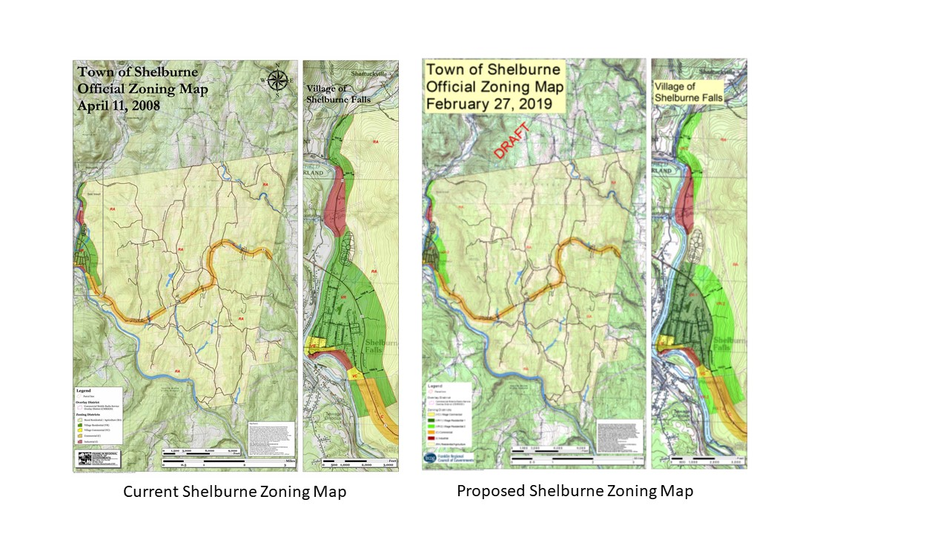

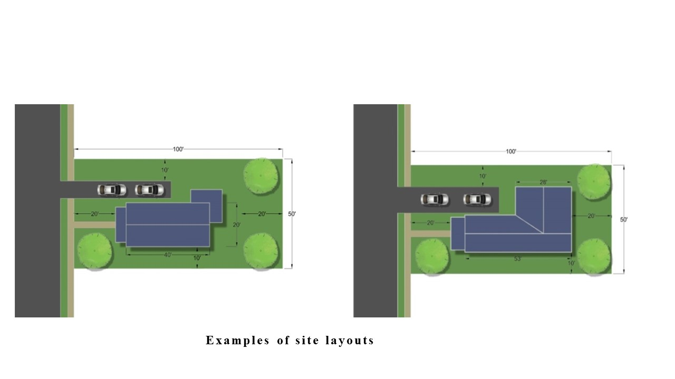

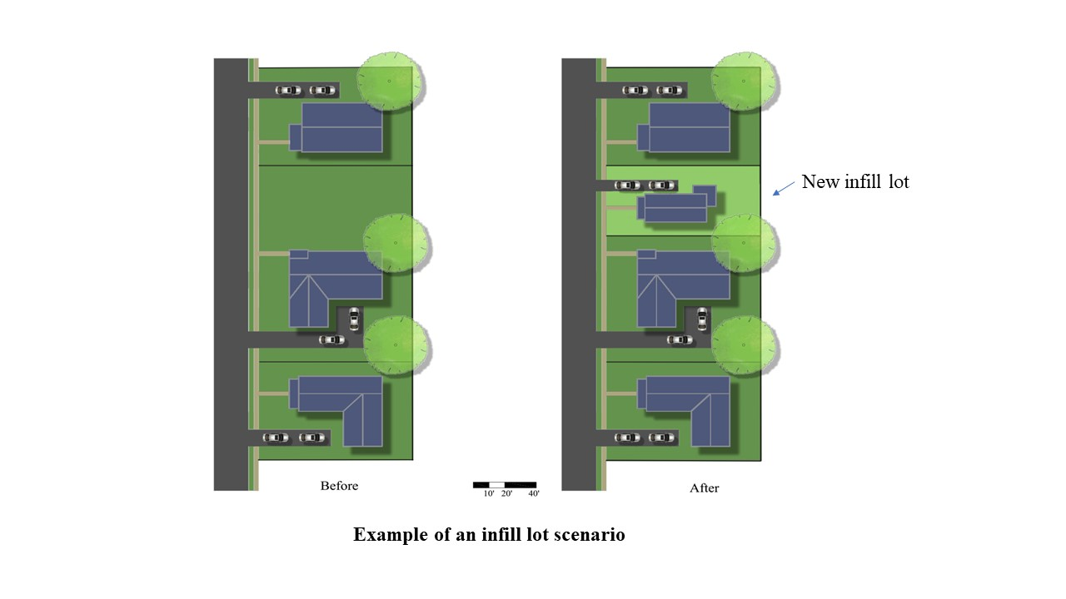 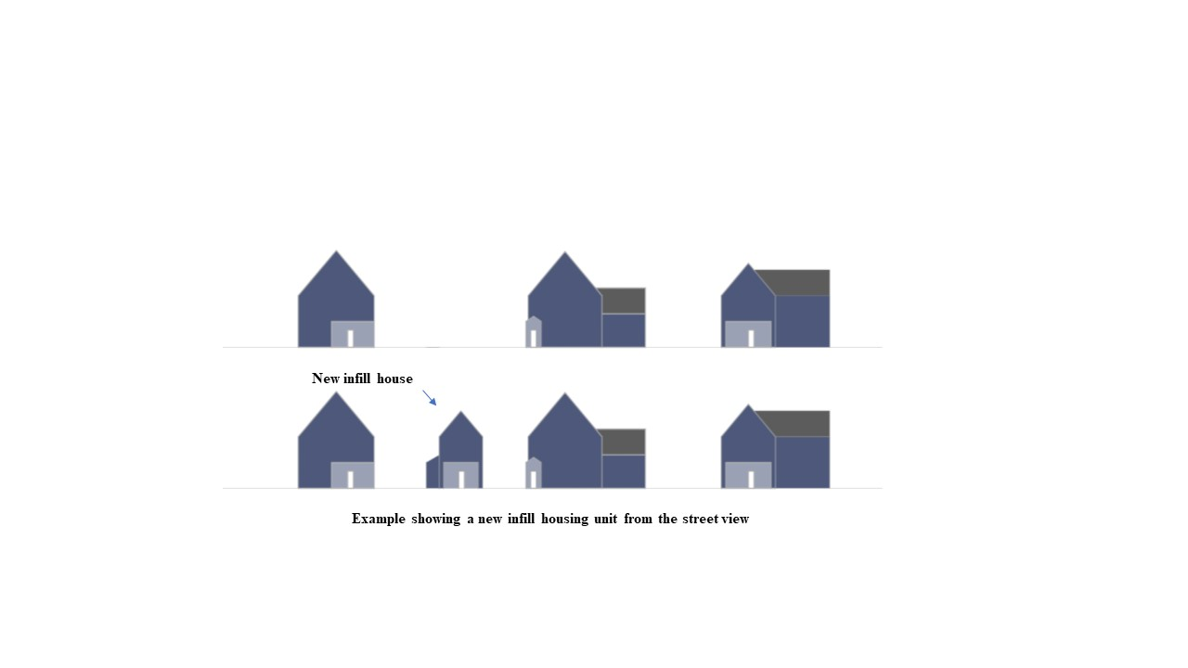

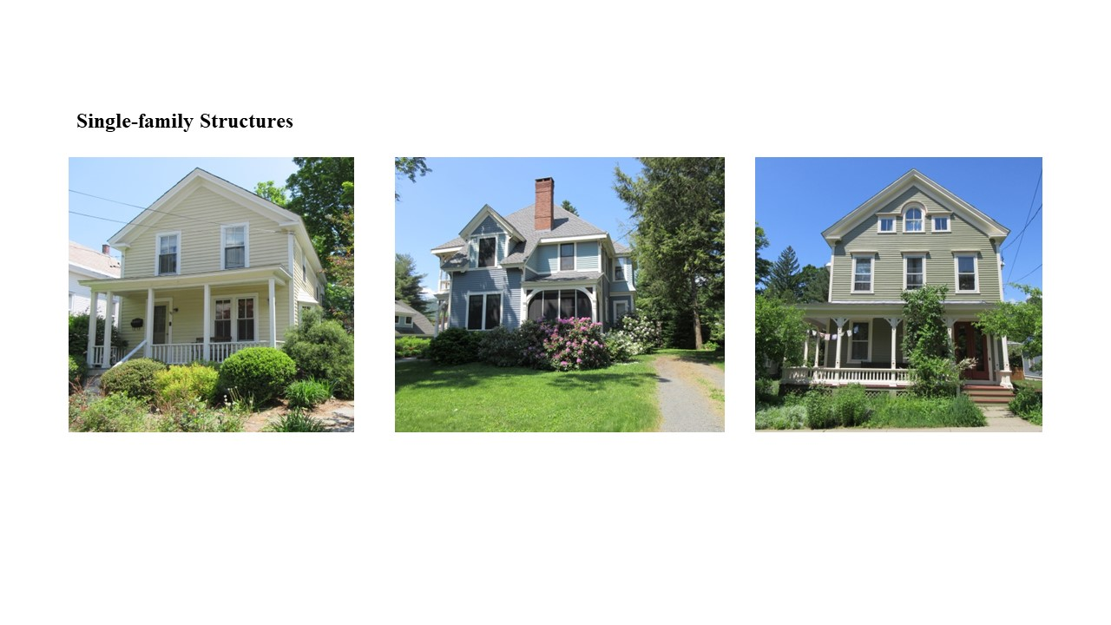

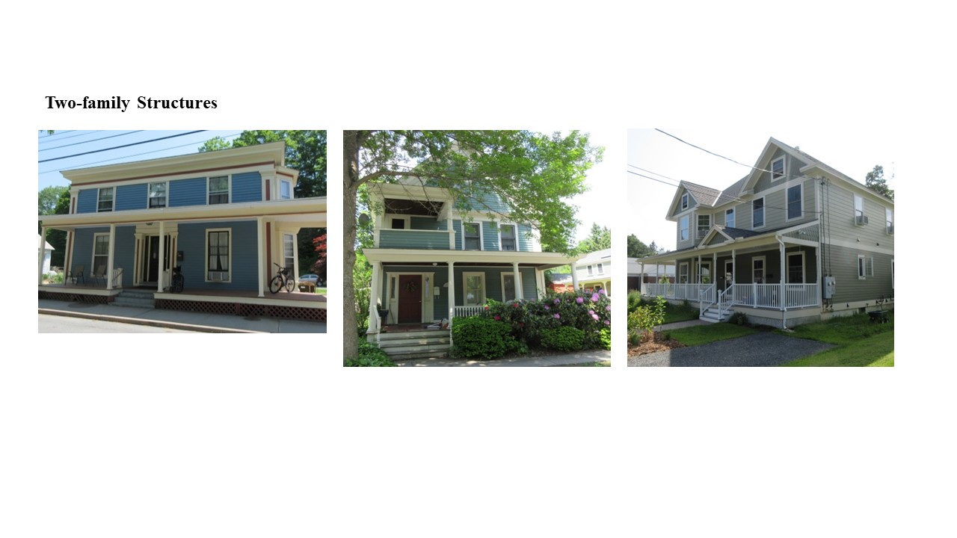 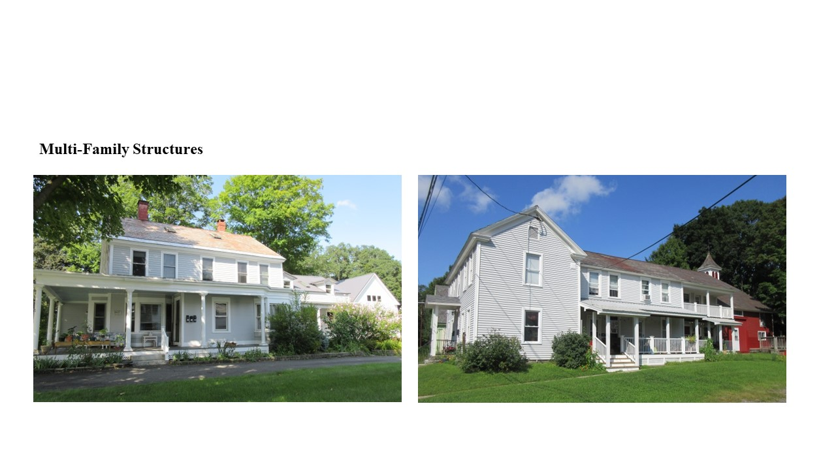 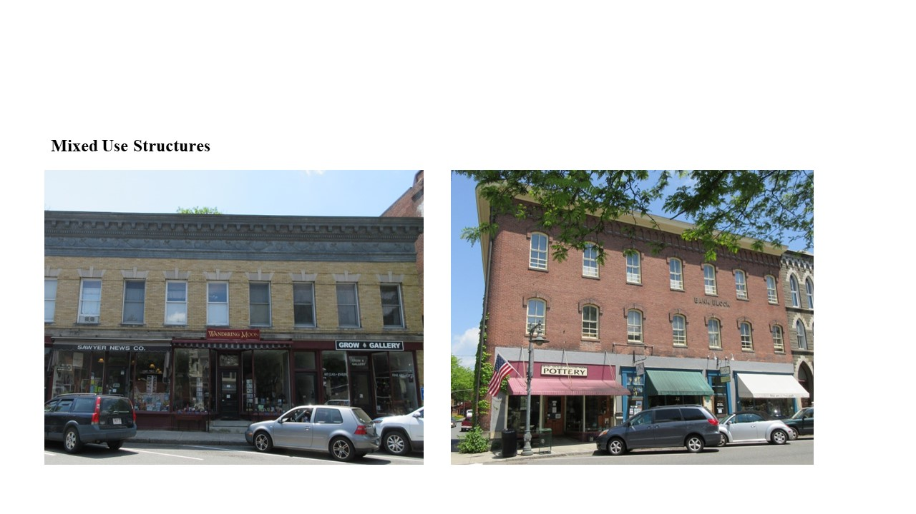

1. An architectural term that means the 3-dimensional form of a structure.